­­

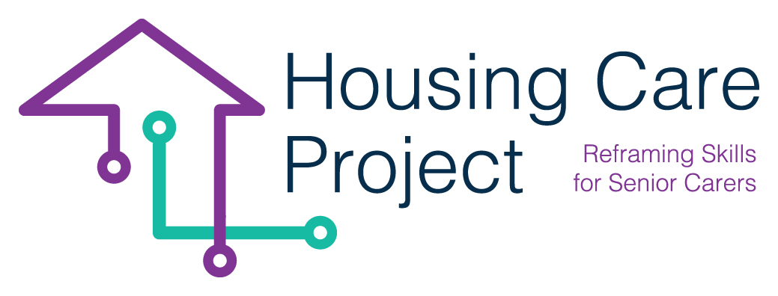

contents

**01** PROCESSESS AND TUTOR CHECK LIST 6



The European Commission support for the production of this publication does not constitute an endorsement of the contents which reflects the views only of the authors, and the Commission cannot be held responsi­ble for any use which may be made of the information contained therein 2021-1-IT01-KA220-VET-000032949

| PROCESSESS and tutor check list

Resp. Ilmiolavoro

The expected process are:

* *WBL training design*
* *Management and monitoring*

Here follow the description of these processes. The informative elements are:

* flow-chart in which it is possible to understand what are the expected activities, who does what, the used tools, grid, modules etc.
* a detailed description of each activities

03

PRACTICAL GUIDES

**WBL training design process**

The flow chart 

|  |  |
| --- | --- |
| **Process activities descritption** | |
| 1 | The tutor studys and learns in depth the activities that have to be done to launch and manage the Housing Care WBL Pathway |
| 2 | The tutor have to take in account the designed macro-learning unit |
| 3 | The tutor have to contact the host organization asking a meeting (in presence or online) During the meeting the tutor have to ask the host organization a short description of the senior/s, the needs, available the technologies. The the tutor have to co-individuate with the host organization the WBL activities/experiences that are consistent with Housing Care training pathway. For each WBL activities/experiences the tutor should define the expected Performance. The the tutor can connect the shared WBL activities/experiences with the expected Learning outcomes defined in the Macro Learning Unit At the end the tutor have to ask the host organization if there are some specific rules or law related the safe and security dimension |
| 4 | The tutor invites the care worker to do the self-assessment. The care worker does it autonomously |
| 5 | The tutor organize a meeting (in presence or online) with the host organization and the care worker aimed at co-define the terms of the WBL pathway |
| 6 | The tutor, based on the type of care worker, individualize her/his WBL learning pathway |
| 7 | The care worker accept and validate the individualized learning plan |
| 8 | The tutor co-define with the care worker the calendar fo the WBL pathway. It can be 7 weeks or 4 weeks long |

**Management and monitoring process**

The flow chart



|  |  |
| --- | --- |
| **Process activities description** | |
| 1 | Plan the daily schedule for working on the Housing Care Project.  Analyzing the tools, clients, time available e.g. smartphone, tablet, smart TV, age and ability of client, how much time is available with each client.  Identify client interests to tailor activity.  Identify any additional tools or training that may be required. |
|  |
| 2 | TUTOR - explain to care worker what the formative assessment will involve and what is required from them. Reference back to Guildlines and MOOC where possible (as information is already there and they have already completed learning). Reflection and discussion with tutor and care worker is very important, identiy any area which may need to be reviewed, other ways the tutor can help the care worker learn.  CARE WORKER - Reflection and discussion will help identiy any area which may need to be reviewed and other ways in which to learn. Option to link in with tutor at any time with queries, concerns. |  |
| 3 | TUTOR - Learner Log to note any queries as they arise, online or paper based option. Group discussions via online Zoom, Whatsapp etc |  |
| 4 | TUTOR - Invite the care worker to do the final self assessment questionnaire.  CARE WORKER - Does the final self assessment questionnaire |  |
| 5 | TUTOR - Invite the care worker to do the Quality feedback form.  CARE WORKER - Does the Quality feedback form |  |
|  |
| 6 | TUTOR - Does the final report where he or she describes quantitative data and qualitative information related the implemented WBL pathway |  |

**WBL Pathway check list**

In order to ensure that the tutors implement the tutoring processes correctly while maintaining the shared standard, a check list was created. Using it, the tutors will be able to:

- develop a systemic awareness of the activities to be implemented;

- know each single activity;

- implement every planned activities;

- check if some activities have not been implemented.

**Check list n° 0 - WBL Pathway check list**

|  |  |  |  |
| --- | --- | --- | --- |
| **ACTIVITY** | **TICK** | **DATE** | **SIGNATURE** |
| **Before WBL Activities** | | | |
| 1. You have promoted the WBL programs for the involvement of the host organizations and you acquired the availability of some of them |  |  |  |
| 2. You have contacted the Care Workers that participated the MOOC and you have proposed her/him to do the Self Assessment tool |  |  |  |
| 3. You have contacted the Care Workers that have done the Self-Assessment tool in order to understand if they know an available host organization/family |  |  |  |
| 4. You have matched the care workers that don’t have an available host organization with the available host organization |  |  |  |
| 5. You created the calendar of the WBL pathway related the single care-worker |  |  |  |
| 6. You launched the WBL pathway |  |  |  |
| **During WBL activities** | | | |
| 1. You have met the host organization and the care worker to co-plan the WBL pathway starting from the learning outcomes |  |  |  |
| 2. You have met the care worker to design the individualized WBL pathway |  |  |  |
| 3. You have shared with the care worker and with the host organization the WBL pathway calendar (30 hours) |  |  |  |
| 4. You launched the WBL pathway |  |  |  |
| 5. You have monitored the care workers WBL learning activities during the WBL pathway through an in presence or online meeting and on the base of the management and monitoring plan |  |  |  |
| 6. You have communicated the monitoring activities to the interested parties (the responsible of project partner staff, learner/care worker...) |  |  |  |
| 7. You have completed the formative assessment |  |  |  |
| 8. You have the evidence the care worker has ended the WBL pathway |  |  |  |
| 9. You have done the monitoring report with the most important information acquired during the monitoring meeting |  |  |  |
| 10. You have asked the Care Workers to do the final Self-Assessment tool |  |  |  |
| **ACTIVITY** | **TICK** | **DATE** | **SIGNATURE** |
| **After WBL activities** | | | |
| 1. You have evaluated the need for modification, correction, remodulation path and, if necessary, has modified, corrected, reshaped the path |  |  |  |
| 2. You have reported the progress of the WBL pathway to the learner/care worker |  |  |  |
| 3. You have prepared a final monitoring report (comment on the results) |  |  |  |
| 4. You have ensured that the care workers have received the certificate of competence |  |  |  |

The tasks of the tutors is outlined below in some frameworks. They could be helpful as alternative tools to the checklist above. Their main quality is they provide an overview of the tasks to be performed by the tutors.







