­­

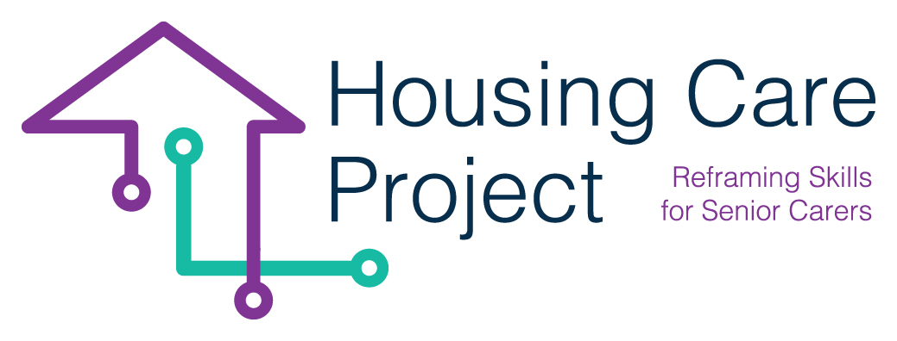

contents

**01** **WBL Co-design with the hosting organization** 6



The European Commission support for the production of this publication does not constitute an endorsement of the contents which reflects the views only of the authors, and the Commission cannot be held responsi­ble for any use which may be made of the information contained therein 2021-1-IT01-KA220-VET-000032949

| Tool n. 3 WBL Co-design with the hosting organization

Resp. Ilmiolavoro

**Co-designing with host organization**

As it is well known, the planning of the WBL pathway must be developed with the active involvement of the host organization (family, healthcare home etc). In order to facilitate and to standardize the co-planning process, a grid has been created to identify:

* the main activities which the learner/care worker will carry out;
* what the learner/care worker will have to prove to be able to do at the end of the learning pathway;
* “translate” learning outcomes indicated by the host organization into training standards;
* the evidence related to each learning outcome.

**Tool n. 3 WBL Co-design with the hosting organization**

|  |  |  |  |
| --- | --- | --- | --- |
| **SECTION 1** | | | |
| Host Organization: | | Location: | |
| Contact Person: | | Contact Phone: | |
| Email Address: | |  | |
| **Type of host organization**  ☐ Seniors alone ☐ Seniors in a family ☐ Socio-medical residence ☐ Technology company ☐ Other: | | | |
| **Area(s) in which the learner/care worker would focus during WBL** | | | |
| ☐ Material care and support  ☐ Health care  ☐ Other __________________________. | | | |
| **SECTION 2** | | | |
| **Content of the WBL activities:**  Indicate the **main activities** (3/4 no more) in which the learner/care worker can be involved, **what he/she has to be able to know/ to do for each activity (LEARNING OUTCOMES)**, what he has to produce (**OUTPUT**) to demonstrate it. | | | |
| **MAIN ACTIVITIES IN WHICH THE LERNER/CARE WORKER WILL BE INVOLVED** | **LEARNING OUTCOMES** | | **OUTPUT/PERFORMANCE** |
|  |  | |  |
|  |  | |  |
|  |  | |  |
|  |  | |  |
|  |  | |  |
| Pre-requisites professional skills, knowledge and personal competences requested before WBL path startig | |  | |
| Regulations | | Safety and laws | |
|  | |  | |