­­

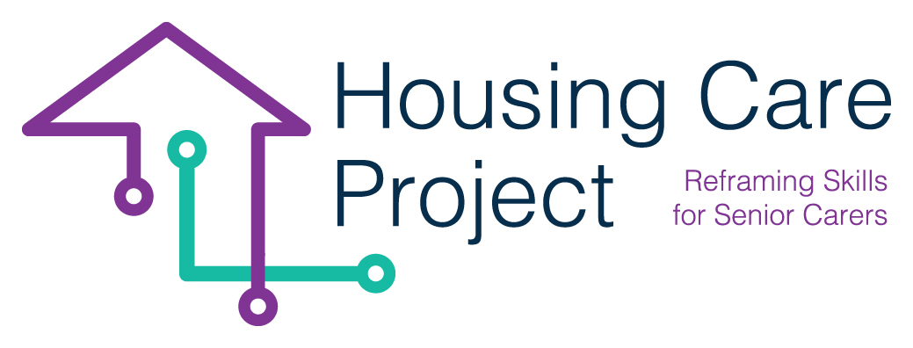

contents

**01** **Tool n. 4 – Individualized plan** 3



The European Commission support for the production of this publication does not constitute an endorsement of the contents which reflects the views only of the authors, and the Commission cannot be held responsi­ble for any use which may be made of the information contained therein 2021-1-IT01-KA220-VET-000032949

| Tool n. 4 – Individualized plan

Resp. ilmiolavoro srl

**CREATION OF INDIVIDUAL WBL PATHWAY (PLAN)**

Below is the grid that allows you to draw up a work-based learning pathway in an individualized way. The information you have to put in the grid are situated in different sources.

**Tool n. 5 – Individualized plan** 

|  |
| --- |
| ***Name surname of the learners/care workers*** |
|  |
| ***Learners’ talents and passions***  *What activities do you like doing? (Think of those activities that, when you do them, you feel a psychological well-being. They are not tiring activities for you).*  *What are your talents? (Think of those activities that you always do well. You always get good results. You don’t need to put a lot of effort in doing them, you have innate abilities to do them).* |
|  |
| ***Individualized learning outcomes*** *(in line with the content you put on the Grid n. 6 Co-planning with the host organization you can choose the learning outcomes that fits with the profile of the care worker as individual)* |
|  |
| ***Planned activities in the host organization - co-planning grid***  *(in line with the content you put on the Grid n. 3 Co-planning with the host organization you can choose the learning outcomes that fits with the profile of the care worker as individual)* |
|  |