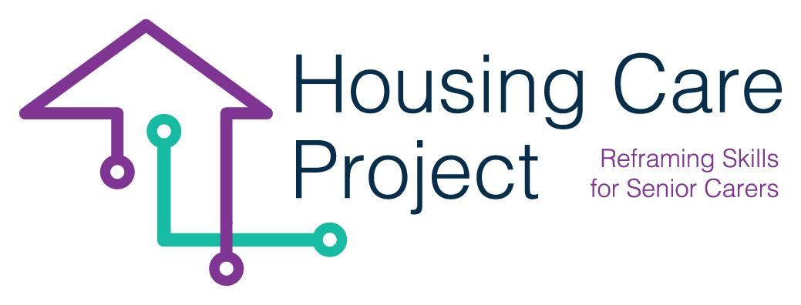

g
2022 – 2024
Human-Digit WBL Toolkit

By
Ilmiolavoro srl
https://housingcare.net
Calendar template
Project result n. 2
Housing Care Project

contents

01 Calendar template 3

The European Commission support for the production of this publication does not constitute an endorsement of the contents which reflects the views only of the authors, and the Commission cannot be held responsible for any use which may be made of the information contained therein 2021-1-IT01-KA220-VET-000032949

01
Tool n. 5 – Individualized plan

| Calendar template
Resp. ilmiolavoro srl

Below there are two templates of the calendar you have to create for each single care workers.
The first template refers to a 4-weeks calendar, the second to a 7-weeks calendar.
In both scenarios, the duration of the WBL pathway is 30 hours.
After the calendar templates, there are also two calendar frameworks. These are, of course, flexible.

4 weeks long calendar hypothesis (preferred)

Name and surname care worker ___________________________________
Name and surname tutor _____________________________________
WBL Pathway from ___/___/2023 to ___/___/2023
Date | Hours | Notes
___/___/2023 | 4
___/___/2023 | 4
___/___/2023 | 4
___/___/2023 | 3
___/___/2023 | 0,5 | Formative assessment
___/___/2023 | 4
___/___/2023 | 3
___/___/2023 | 0,5 | Monitoring
___/___/2023 | 4
___/___/2023 | 3
Total | 30

7 weeks long calendar hypothesys
Name and surname care worker ___________________________________
Name and surname tutor _____________________________________
WBL Pathway from ___/___/2023 to ___/___/2023
Date | Hours | Notes
___/___/2023 | 2
___/___/2023 | 2
___/___/2023 | 2
___/___/2023 | 2
___/___/2023 | 0,5 | Formative assessment
___/___/2023 | 2
___/___/2023 | 2
___/___/2023 | 2
___/___/2023 | 2
___/___/2023 | 0,5 | Monitoring
___/___/2023 | 2
___/___/2023 | 2
___/___/2023 | 0,5 | Formative assessment
___/___/2023 | 2
___/___/2023 | 2
___/___/2023 | 2
___/___/2023 | 2
___/___/2023 | 0,5
Total | 30

4-weeks calendar template (preferred)

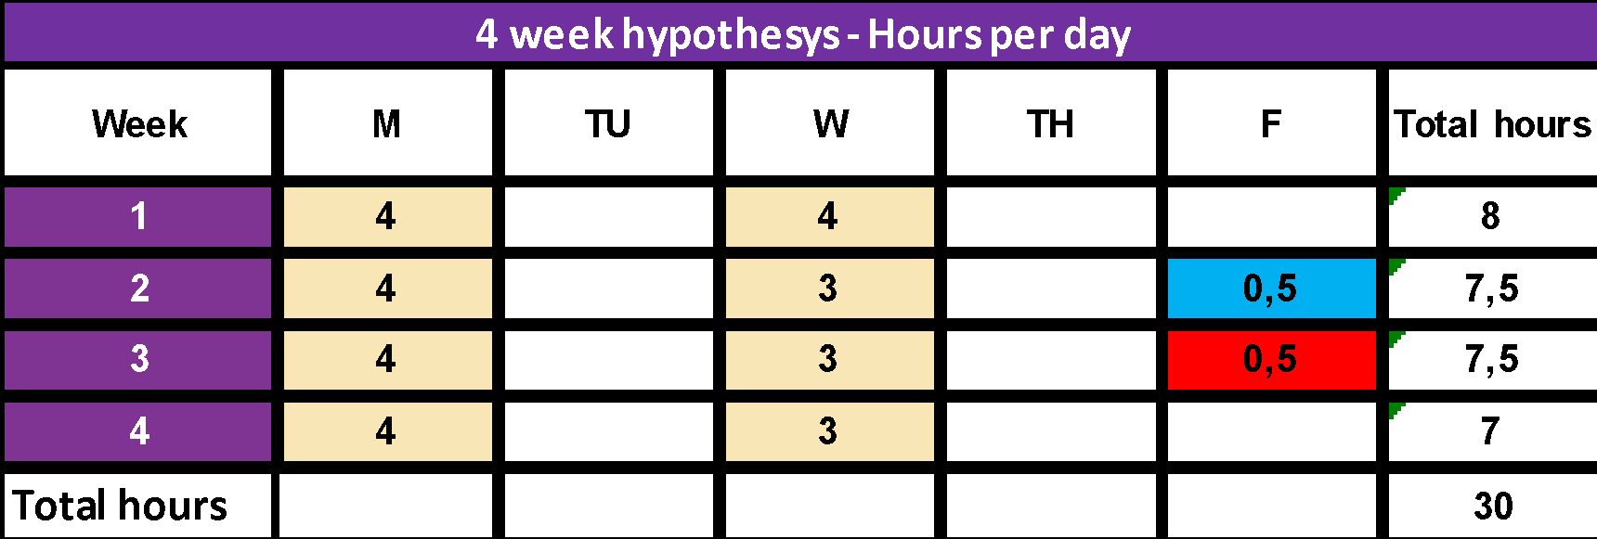

7-weeks calendar framework

