­­

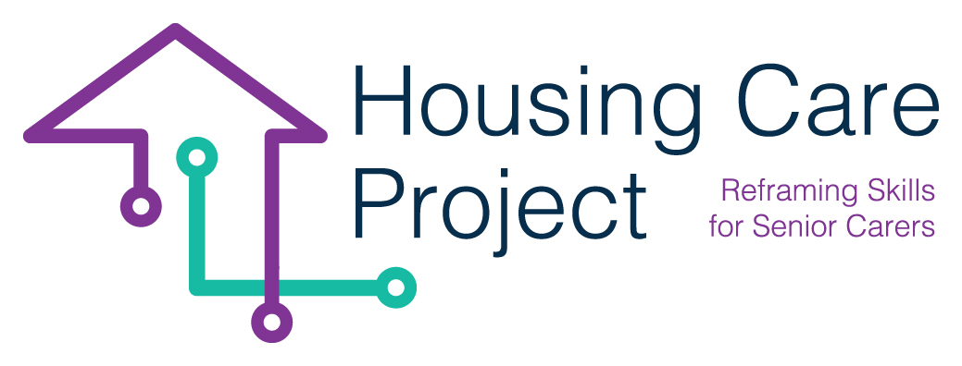

contents

**01** **Guide lines n. 4 How to organize a the meeting**  6



The European Commission support for the production of this publication does not constitute an endorsement of the contents which reflects the views only of the authors, and the Commission cannot be held responsi­ble for any use which may be made of the information contained therein 2021-1-IT01-KA220-VET-000032949

| Guide lines n. 4 How to organize a the meeting (tutor)

Resp. Ilmiolavoro

**Organize a meeting with the host organization**

This tool is for use by the tutor to organize a meeting with the host organization:

* on the workplace;
* on-line.

The meeting is an activity in which learner/care worker have the opportunity to know the workplace, get to know the host organization, meet the senior, ask questions and observe work in progress. It should take place for one learner/care worker and it should involve preliminary preparation. All meetings with the host organizations should include structured activities before, during and after the experience.

Follow some Guidelines the tutor have to use to organize effective meeting.

**Guide lines n. 4 How to organize a the meeting (tutor)**

|  |
| --- |
| ***Before the meeting***   * ***Evaluate how the study visit can help you to achieve your tutor objectives*** *Make sure that the meeting will help learner/care worker understand the context in which they will be challenged, acting as a valuable tool for applying academic concepts learned through the MOOC to work real situations.* * *Select suitable host organization for the work based learning experience. Make sure they are appropriate organizations able to link academic learning acquired through the MOOC to the world of work.* * *Organize in detail the logistical part of the visit* * *Prepare learner/care worker to best maximize their learning:* * *Discuss with them about their expectations about the meeting they are about to accomplish and what they expect to learn* * *Ask learner/care worker to prepare a list of learning questions and goals they would like to accomplish during the meeting.* * *Suggest the learners/care workers the following questions they could do during the meeting:*   + What are the main needs of the senior I have to support?   + What are the tasks that I will have to accomplish during my experience?   + What is the most important thing to learn for me as soon as I start working there?   + When I finish my WBL experience there, what do you hope I will have learned/I’ll be able to do?   ***During the meeting***   * *Ensure that learners/care workers receive information on the learning activities she/he can do in the context of the host organization.* * *Ensure that learners/care workers receive safety instructions at the workplace.* * *Make sure that learners/care workers come into contact with all aspects / environments of the host organization.*   ***After******the meeting***   * *Help learners/care workers understand and determine the next steps of learning their pathway. The meeting allows learners/care workers to discover further elements for the development of their careers.* * *Use host organizations and learners/care workers feedback for continuous improvement of study visit organization* |