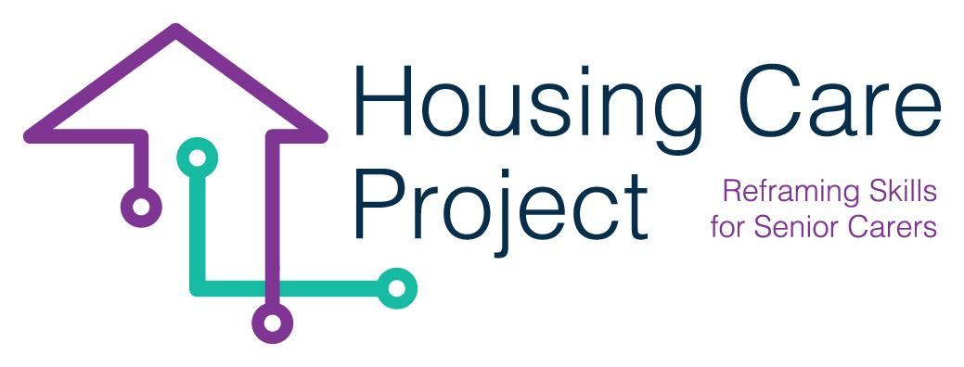

g
2022 – 2024
Human-Digit WBL Toolkit

By
Ilmiolavoro srl
www.housingcare.net
Human-Digit WBL
Tool n. 5 Monitoring visit/online meeting WBL workplace grid
PR 2 Housing Care Project

contents

01 Tool n. 5 Monitoring visit/online meeting WBL workplace grid 3

The European Commission support for the production of this publication does not constitute an endorsement of the contents which reflects the views only of the authors, and the Commission cannot be held responsible for any use which may be made of the information contained therein 2021-1-IT01-KA220-VET-000032949

01
Tool n. 5 Monitoring visit/online meeting WBL workplace grid

| Tool n. 5 Monitoring visit/online meeting WBL workplace grid
Resp. Ageing Lab

MANAGEMENT AND MONITORING PLAN FOR THE WBL PATHWAYS IMPLEMENTATION
The management of the WBL pathways involves monitoring the activities carried out, the learning outcomes achieved and the ability to manage and resolve critical issues that may occur.

The monitoring plan is developed for single learner/care worker:

- the activities expected in the WBL path will be monitored
- for each activity monitored, indicate:
- the forms of collection of data (Visit to the host organization in presence or online: learner/care worker observed on the task; Visit to the host organization: meeting with the learner/care worker; Data collection from documents, learner/care worker interview);
- Data and information collected (Activity progression time, type of activity; learning progression-formative assessment; consistency of activities with the plan, difficulty)
- Tools used (WBL Monitoring grid for visit; WBL activity detection grid)
- Time of implementation of monitoring activities.

The monitoring activity can be done through meeting between the tutor and the learner/care worker. The tutor can organize the meeting in two ways:
- In presence on the workplace, it means a visit;
- Online on the workplace, it means a video-call.
At least one meeting each learner/care worker have to be carried out. During the meeting the tutor should use the following grid.

Tool n. 6 Monitoring visit/online meeting WBL workplace grid
GUIDE: the grid can be used to check the progress of the learning path in the workplace. The tutor verifies both the progress of Learning outcomes and the activities carried out (Tasks and activities). This monitoring activity must be done through questioning and observation or through interview addressed to the learner/care worker.

Monitoring grid visit (online or in presence) WBL Workplace
Learner/care worker:

WBL tutor | Date and time
☐ Learner/care worker observed on the task

☐ Meeting with the Learner/care worker
Area covered by the visit | Revision and comments
Learner/care worker’s General Performance
Activities and tasks
Recommendations from the WBL tutor

Recommendations from learner/care worker

Commitment in follow up

Other activities, discussions

Next monitoring meeting

