­­

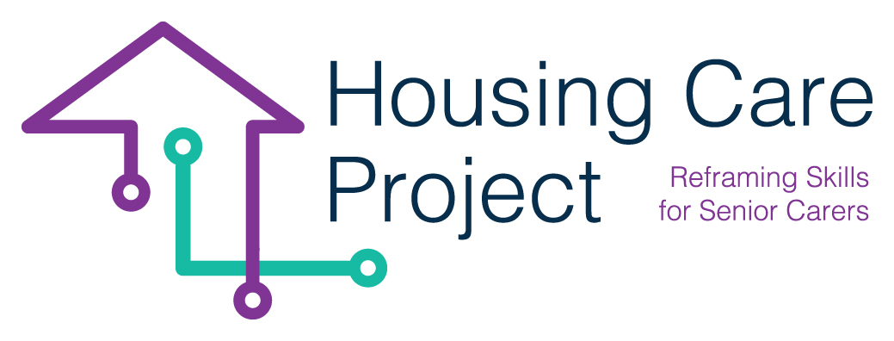

contents

**01** **Grid n. 1 Give and communicate formative feedback (for tutor)** 3



The European Commission support for the production of this publication does not constitute an endorsement of the contents which reflects the views only of the authors, and the Commission cannot be held responsi­ble for any use which may be made of the information contained therein 2021-1-IT01-KA220-VET-000032949

| Grid n. 1 Give and communicate formative feedback (for tutor)

Resp. Ageing Lab

**Grid n. 2-** **Give and communicate formative feedback (for tutor)** 

|  |  |
| --- | --- |
| **Feedback**  **levels** | **Questions for further information and to infer new reflection** |
| *Learner/care worker outcomes* | - Are the results obtained in an activity satisfying the success criteria?  - Are the results of the learner/care worker correct? Why yes, why not?  - How did the learner/care worker elaborate the contents of the care service / task?  - What did you appreciate about what the learner/care worker did in terms of care service?  - Where is the error?  - What did the learner/care worker do better?  - What knowledge does the learner/care worker need in order to do better? |
| *Learning process* | - What didn’t he do correctly and why?  - What information, contained in the delivery, did he not examine?  - What strategies did he you use?  - What justifies the correctness of a job?  - What explanations should be given to justify the correctness of a job?  - What must the student wonder to understand how to do a proper job?  - What relationships are there between the different parts of the task?  - What is the level of understanding of the concepts and knowledge related to the task? |
| *Self assessment*  *And*  *Self learning adjustment* | - How can the learner/care worker review his work?  - How can the learner/care worker perform systematic checks while performing a task?  - What ideas is the learner/care worker making about the feedback and the indications he receives?  - How can the learner/care worker reflect on his / her learning?  - What did the learner/care worker do for ...?  - What happened when ...?  - What explanation can be given for ...?  - What doubts does the learner/care worker still have about the work to be done?  - How is this task related to ...?  - What do all these indications have in common?  - After examining his work (the answer) what does the learner/care worker think he has learned?  - How has your way of thinking about the problem changed and doing the job?  - Can the learner/care worker teach another student? How and what ...? |

*Adapted from:* Hattie J., *(2012). Visible learning for teachers. Maximizing impact on learning,* London, Routledge, p. 129