­­

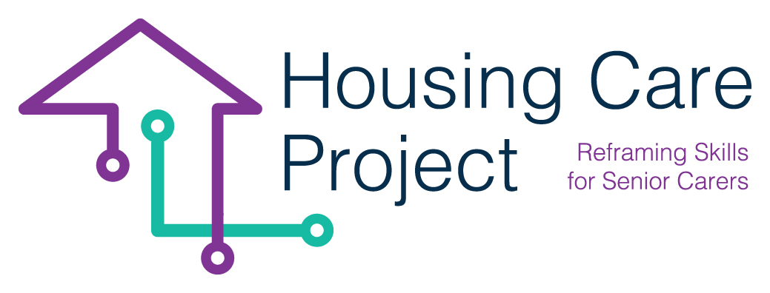

contents

**01** **Grid. N. 2 Learner/care worker grid to receive formative feedback** 3



The European Commission support for the production of this publication does not constitute an endorsement of the contents which reflects the views only of the authors, and the Commission cannot be held responsi­ble for any use which may be made of the information contained therein 2021-1-IT01-KA220-VET-000032949

| Grid. N. 1 Learner/care worker grid to receive formative feedback

Resp. Ageing Lab

***Grid. N. 3 – learner/care worker grid to receive formative feedback*** 

|  |  |
| --- | --- |
| **Feedback**  **levels** | **Questions for further information and to infer new reflection** |
| *Learner/care worker outcomes* | - How was it? What did I do well, what did not?  - What was the goal of the job?  - After some task, what will be the next step?  - What goal can I give me? |
| *Learning process* | - How did I "work"?  - What did I miss during the "work"?  - Where and when did I lose control of what I was doing?  - When didn’t I lose control and how things went |
| *Self-assessment*  *And*  *Self adjustment of learning* | - Why did it happen?  - What have I been good at and why?  - Which parts of the procedure should I improve?  - What additional knowledge do I need? |