­­

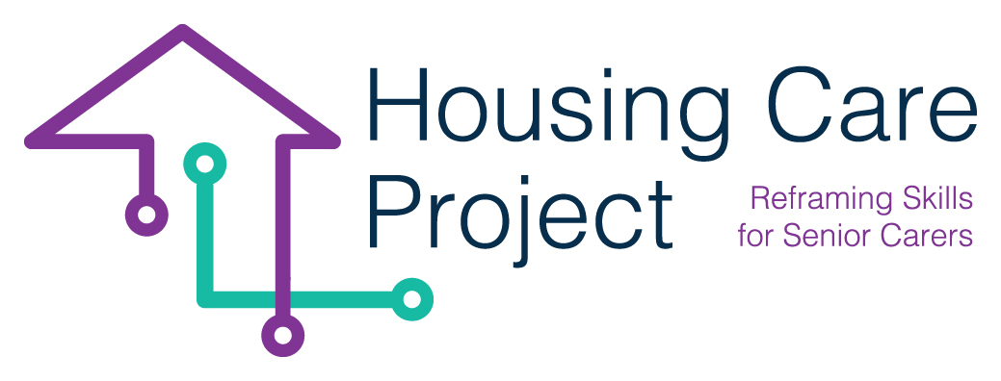

contents

**01** **Grid. N. 3 Learner/care worker grid to receive formative** 3



The European Commission support for the production of this publication does not constitute an endorsement of the contents which reflects the views only of the authors, and the Commission cannot be held responsi­ble for any use which may be made of the information contained therein 2021-1-IT01-KA220-VET-000032949

| Grid. N. 3 Learner/Care worker grid to receive formative feedback

Resp. Ageing Lab

**Grid. N. 3 – Learner/Care worker grid to receive formative feedback**

|  |  |  |  |  |  |  |  |  |  |  |
| --- | --- | --- | --- | --- | --- | --- | --- | --- | --- | --- |
| **Feedback Levels** | **Learner/care worker outcomes** | | | | | | | | | |
| **Are you satisfied with the results of the activities that you carried out between the last formative feedback and until now to date?** | **NO** | | | **Maybe** | | | | **YES** | | |
| **Do you think that your users (seniors) are satisfied with the results of this WBL until now?** | **NO** | | | **Maybe** | | | | **YES** | | |
| **In your opinion, how did you feel doing these tasks?** | **I need more support-training** | | **I feel I am doing ok** | | | | | | | |
| **Do you believe that you are reaching the expected goals?** | **NO** | | | **Maybe** | | | | **YES** | | |
| **Do you consider that you are developing the correct skills in order to reach the expected goals?** | **NO** | | | **Meaybe** | | | | **YES** | | |
| **Do you have problems incorporating technology into your day-to-day work?** | **NO** | | | **Sometimes** | | | | **YES** | | |
| **What would you need from now on to improve and feel more confident in your work through the technology provided?** |  | | | | | | | | | |
| **What type of technology have you found most useful in your job to date?** |  | | | | | | | | | |
| **Feedback Levels** | **Learning process** | | | | | | | | | |
| **Are you keeping a diary of your activities and tasks?** | **NO** | | | | | **YES** | | | | |
| **Explain briefly the activities that you carried out between the last formative feedback and this.** |  | | | | | | | | | |
| **During this period what kind of technology you used during your job?** |  | | | | | | | | | |
| **In some cases, were you unable to carry out the planned task with the elders? If yes, briefly explain what happened.** |  | | | | | | | | | |
| **Have you ever felt that the training was getting out of control?** | **NO** | | | **Maybe** | | | | **YES** | | |
| **When you lose the control, what you did? What did you do to solve it?** |  | | | | | | | | | |
| **Do you think you can carry out the WBL and your work at the same time without interference between them?** |  | | | | | | | | | |
| **There are some kinds of technology that you haven’t used in your job? If yes, Witch and Why?** |  | | | | | | | | | |
| **Feedback Levels** | **Self-assessment**  **And**  **Self-adjustment of learning** | | | | | | | | | |
| **Does the work-based learning programme provide real-life work experiences for Care Workers?** | **Not at all** | **slightly** | | | **Moderately** | | **something** | | | **Absolutely** |
| **Do you think that the technology provided is useful to improve the life of seniors?** | **Not useful at all** | | **Somewhat useful** | | | **Moderately useful** | | | **Very useful** | |
| **Do you think that the technology provided is useful to improve your work?** | **Not useful at all** | | **Somewhat useful** | | | **Moderately useful** | | | **Very useful** | |
| **To what extent do you think your understanding of home care technologies has improved through this WBL?** | **Not improved at all** | | **Somewhat improved** | | | **Moderately improved** | | | **Significantly improved** | |
| **How relevant do you think the content of the WBL is to your work?** | **Not relevant** | | **Somewhat relevant** | | | **Moderately relevant** | | | **Very relevant** | |
| **During this period, do you feel that you should improve in some skills regarding about your job and technology? Explain briefly** |  | | | | | | | | | |
| **Value yourself with the follow skills/abilities** | | | | | | | | | | |
| **Manage Smartphones/Tablets/Smart TV** | **Too bad, I need improve a lot of things** | | | **Depends, I need improve just few things** | | | | **Very good, I don't need to improve anything.** | | |
| **Tecno-security (online data management, user support...)** | **Too bad, I need improve a lot of things** | | | **Depends, I need improve just few things** | | | | **Very good, I don't need to improve anything.** | | |
| **Management of the different apps proposed** | **Too bad, I need improve a lot of things** | | | **Depends, I need improve just few things** | | | | **Very good, I don't need to improve anything.** | | |
| **Communication Skills through technology (effective digital communication)** | **Too bad, I need improve a lot of things** | | | **Depends, I need improve just few things** | | | | **Very good, I don't need to improve anything.** | | |
| **Communication Skills (Empathy, active listening…)** | **Too bad, I need improve a lot of things** | | | **Depends, I need improve just few things** | | | | **Very good, I don't need to improve anything.** | | |
| **Management time** | **Too bad, I need improve a lot of things** | | | **Depends, I need improve just few things** | | | | **Very good, I don't need to improve anything.** | | |
| **Abilities to motivate seniors** | **Too bad, I need improve a lot of things** | | | **Depends, I need improve just few things** | | | | **Very good, I don't need to improve anything.** | | |
| **Abilities to work with the rest of the team** | **Too bad, I need improve a lot of things** | | | **Depends, I need improve just few things** | | | | **Very good, I don't need to improve anything.** | | |
| **Promoting senior’s autonomy** | **Too bad, I need improve a lot of things** | | | **Depends, I need improve just few things** | | | | **Very good, I don't need to improve anything.** | | |

The grid can be used by the learner/care worker accompanying the logbook:

● every day;

● every week;

● at an intermediate time;

● in a final moment.

The answers must be noted by the learner/care worker in the logbook.