07
EQAVET+ guidelines

| 7. EQAVET+ guidelines
Resp. Ilmiolavoro srl supported by all partners

The reference
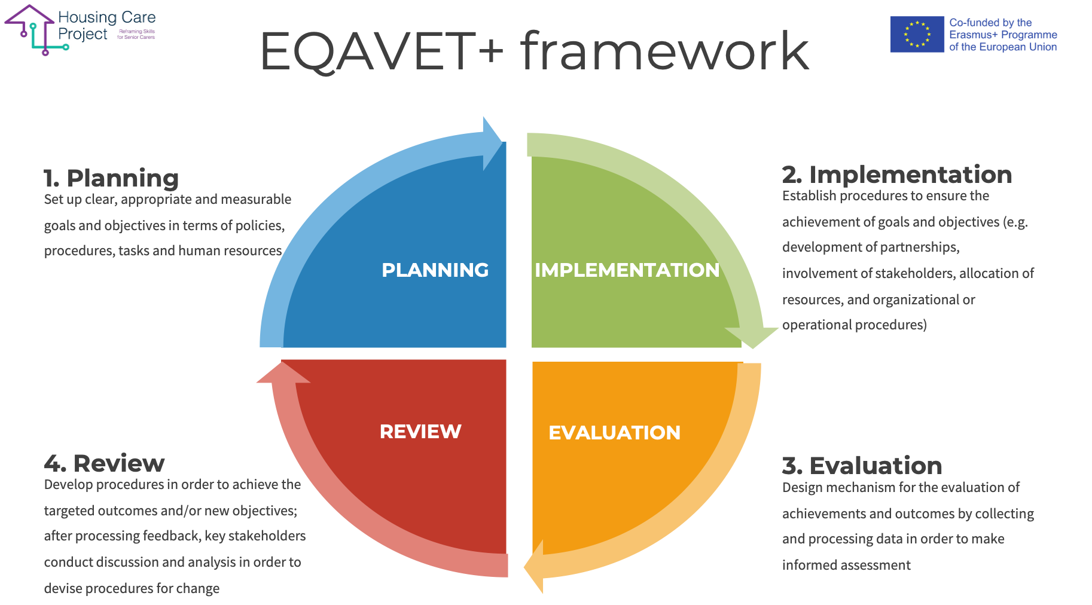

Editable graphic

Guidelines on Quality Assessment and Self-Assessment in line with the updated EQAVET+ framework

In order to implement quality procedures before, during and after the WBL pathway, we have prepared the following checklist with the aim of helping anyone - with a responsibility in the coordinating and in the guidance of WBL pathways - to carry out the activities required.

The checklist should be used by the workplace tutor: every time one of the planned activities is completed, the tutor can put a check mark, insert the date and sign. This tool will also allow one to check if something hasn’t been carried out or has not been carried out after the deadline.

Checklist n 2 EQAVET procedures before, during, and after the WBL

ACTIVITY | TICK | DATE | SIGNATURE
Before WBL Activities
You have promoted the WBL programs for the involvement of the host subjects | ☐
You have acquired the availability from the host subjects to host organisation/family visits | ☐
You have developed a WBL pathway starting from the learning outcomes | ☐
You have developed one or more Learning Units starting from the learning outcomes | ☐
ACTIVITY | TICK | DATE | SIGNATURE
During WBL activities
You have prepared the learners/care workers for the WBL pathway
You have developed an individualised project starting from the learning outcomes
The individualised project has been approved/shared by the learner/care worker
You have drawn up the management and monitoring plan
You have communicated the monitoring activities to the interested parties (WBL tutor, learner/care worker...)
You have carried out the activities of WBL at the host organisation
You have completed the formative assessment
You have updated the monitoring results
You have evaluated the need for modification, correction, remodulation path and, if necessary, have modified, corrected, or reshaped the path
(effectiveness evaluation and improvement plan)
You have reported the progress of the WBL pathway to the learner/care worker
You have prepared a final monitoring report (comment on the results)
ACTIVITY | TICK | DATE | SIGNATURE
After WBL activities
You have certified the skills developed by the learner/care worker | ☐

