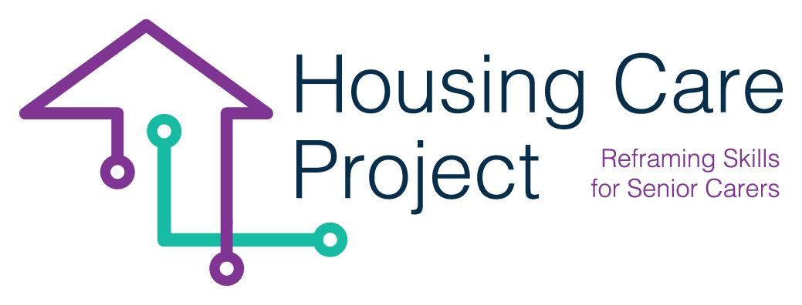

g
2022 – 2024
Human-Digital WBL Toolkit

By
Ilmiolavoro srl
www.housingcare.net
Human-Digital
WBL Toolkit
Project Result No. 2
Housing Care Project

contents

00 Introduction ………………………….… 2
The European Commission support for the production of this publication does not constitute an endorsement of the contents which reflects the views only of the authors, and the Commission cannot be held responsible for any use which may be made of the information contained therein 2021-1-IT01-KA220-VET-000032949

01 The WBL Learning Unit ………….… 6
02 Self-assessment tool…………….…... 7
03 Practical Guides ………….… 9
04 Tutor Guidelines ………….… 9
05 Tutor training curricula ………….… 9
06 Training Materials ………….… 9
07 EQAVET+ Guidelines ………….… 9
| INTRODUCTION

Resp. Ilmiolavoro

The toolkit is a project result of the HOUSING CARE project implemented after the development of the MOOC, it was created to reskill senior care workers on emerging technologies in the senior care sector.
The toolkit meets the need for skills development and practical mastery of senior care workers involved in the MOOC. It can only take place in a work-based context.
The toolkit contains a set of helpful tools to design and implement practical learning activities addressed to Senior Care Workers. It is implemented in a work-based pathway including:
- Care and treatment delivery through the use of Senior Care technologies;
- Tutoring and trainer support.

It will also include contents, activities and tools aimed at trainers who will support the Senior Care Workers (the target group of the project – TG) in the work-based learning experience. The toolkit is digital and it contains:
- Training curricula related to the WBL Training & Activities, implemented to train the training designer and the trainers as tutors;
- Training materials used to train the training designer and the trainers during the LTTA;
- Tutoring guidelines (process, WBL design guidelines, tools, checklists, grids, control and support tools, skills certification, self-assessment and quality evaluation);
- WBL learning unit, that includes:
o Expected learning outcomes
o Description of work-based learning activities/experiences in six areas of activities;
o Learning assessment process;
o Competence certification process.
- Training materials used by care workers in the WBL pathway:
A. Practical guide on the use of Senior Care technologies, on the use of Apps (to stimulate cognitive skills, to support physical activities, medication adherence, for leisure and social life, for healthy lifestyles, for efficiency and wellbeing of the care worker etc.) and of innovative and handy devices, to be used in home and or residential care, E-Health platforms and devices for monitoring vital parameters etc. (teleassistance, telecare, telemonitoring etc.)

B. Practical guide on social & emotional skills integrated with technological skills. This is an easy and practical tool containing a series of tips and suggestions on the best behaviours and attitudes to adopt in certain situations when using technology. It recalls the Human Care Mindset already learned through the MOOC.
- Self-assessment tool through which care workers will be able to assess their initial and final level of mastery.
- Guidelines on Quality assessment and self-assessment in line with the updated EQAVET+ framework.

The toolkit is available as a unique document and as a collection of single tools on the project website https://housingcare.net.

01
THE WBL LEARNING UNIT

| Housing care macro learning unit
Resp. Ilmiolavoro

The learning unit is a helpful tool through which the tutors can design the work-based learning (WBL) experience of the care workers. The learning unit is a reference, it contains the planned learning outcomes and some possible WBL experiences. So the tutors will have part of the training design.

Housing Care Macro Learning Unit

Housing Care Learning unit
Title | Human digit senior care work-based learning
Service Performance | Report the service performance the learner/care worker has to provide
Measurable and specific Learning Outcomes | At the end of the work-based learning pathway, the care worker will be able:  - to master the use of relevant technological devices and Apps on active and healthy ageing, useful to care for seniors during their care service  - to individualise the benefits, the opportunities and the potential functionalities of the technologies and Apps and to select the most suitable to match senior needs during their care service  - to update and make downloads as required during the health and social care service  - to keep their technologies updated  - to deal with GDPR / confidentiality of the senior using the technologies/Apps  - to establish a proper connection and communicate with effectiveness with the seniors  - to communicate effectively in a virtual environment with the seniors relatives, friends, health personnel etc.  - to use specific Apps that allow her/him to give importance to self-care and to enhance their own health and well-being during the care service providing  - to manage accessibility on digital devices to guarantee the senior data safety
Targeted and Expected Competences aligned to learning outcomes | - Starting with knowledge of the benefits and functionalities of the technological devices and Apps on active and on healthy ageing, the care worker is able to select those devices and Apps that match senior needs, to master their use keeping them updated  - Starting with knowledge on the effectiveness of helping relationships, the care worker is able to establish proper connections with the seniors and an effective communication with them, the relative, the friends, the health personnel also using virtual communication Apps and dealing with her/his GDPR / confidentiality while use the technologies/Apps  - Based on the importance of own wellness for and effective care service, the care worker is able to use specific Apps that allow her/him to self-care, self manage and to enhance their own health and well-being during the care service providing
Possible Work Based Learning Experiences | Digital technologies for the health field  - Managing older people's health care using Apps  Examples of possible areas of work-based experiences  - Management of health conditions through the use of diabetes applications [connected Learning Outcome (hereinafter abbreviated LOs): (a)]  - Selecting a health management App relevant to the older person's condition [connected LOs: (b) + (c) + (d)]  - Look for, select and use Apps for specific health conditions  - Look for, select and use social Apps  - Look for, select and use Apps and technologies for medication use  - Look for, select and use Apps to support seniors in fitness activities  Examples of possible activities:  - Verify how much the person is able to use the cellphone and ask him/her to implement small activities such as searching for contacts, download an App, searching info on google  - Verify the client‘s main needs, the find correct App to support the monitoring (diabetes,hydration…)  - Download and use an App for aparticular health condition and teach the client how to use them  - He/she supports relatives on using the same Apps  - Check the data and she should also note them along with the time to check if there are alterations  - Create and manage a list with names and Apps using a management tool  - To use PHR App to keep track of the activities (for other caregivers that may come after & for the family’s information)  - To create a calendar of activities done during the week and programmed activities for the family (guidance) during weekend and (optional) to encourage them to use a videocall App to communicate  - Writing down the procedures for the clients  - Set a weekly (daily)plan for receiving phone call and/or video call from the clients or webcall from the relatives  - Make simple videocall  - Using App for managing perscription medicine or other medication  - Managing their intake of water using reminders  - Measuring and registering the blood pressure using technological devices such as smartwatches  - Watching specific to programmes or to functions for helping cognitive decreasing prevention  - Smartphones voice recognition and face to face discussion, activities about communication and stimulation  - To have smartphones zoom, telegram, whatsApp call to cooperate with colleagues  - Using Google calendar to share client's information  - Using a smartphone as a tool for accessibility  - To train accessibility functions: watching tutorial on how to activate accessibility functions  - Explain to clients how to use accessibility on their devices  - Expand their boundaries including the technologies for the health  - Managing physical activity, healthy lifestyle and the prevention of cognitive decline in Seniors [connected LOs: (a) + (b)]  Examples of possible areas of work-based experiences  - Fostering the physical activity of seniors using the following applications (App Rosita, Down dog)  - Fostering the control of seniors’ water balance using the WaterMinder application  - Fostering a healthy lifestyle for seniors by using the following supporting applications (Yuka, Sentab, Mindshift, Dommus)  - Preventing cognitive decline in seniors through the use of the following Applications: (Luminosity, Peak, Skillz for Logic Brain Games)  Examples of possible activities:  - To use a Public Health Records (PHR) App to keep track of the activities (for other caregivers that may come after & for the family to know)  - To encourage the use of videocall Apps to communicate  - To use cognitive Apps linked with calendar  - To use log App to record the specific needs and constraints (professional assessment, first picture of the state)  - To use of fluid intake reminders if careworker find it useful  - To set phone alert triggered by geofence or "friendly call service" (human backup)  - Supporting and facilitating the social activities of seniors  Example of possible areas of work based experiences  - Using interaction/social Apps such as FaceBook, Twitter etc., informing seniors about netiquette principles and the phenomenon of fake news [connected LOs: (a) + (b) + (e)]  - Fostering the entertainment of seniors through the use of some entertainment Apps [connected LOs: (a) + (b)]  - Fostering seniors’ enjoyment of cultural content through the use of some cultural Apps [connected LOs: (a) + (b)]  Examples of possible activities:  - Promote connections with family and care workers (Social networks) using WhatsApp  - Create a Plan regarding social activities in the area (Week) taking into account the likes of the seniors/client  - To look up the technical supports to suit the seniors/client  - keep technology simple, for example, card playing to keep the client stimulated  - Promote intergenerational actions using zoom  - Promote active listening, empathy abilities, in order to give the seniors the opportunity to build trust with the care worker  - Create a plan with meetings schedule with other people  - Create activities in their own town with other people with the same likes and in the same situation  - To use alexa for clients (Cineforum, audiobooks, for the people can't read)

Possible Work Based Learning Experiences | Digi-human competences  - Implementing activities that promote a work-life balance and increase the quality of life [connected LOs: (h)]  Example of possible areas of work based experiences  - Using self-management Apps (Slide 25)  - Watch the tutorials that aid mindfulness, reflect and practice the suggested behaviours (slide 29)  Examples of possible activities:  - Divide the work environment from the private one, and so create time & space to practice mindfulness  - After finishing work, keeping 10 minutes for meditation  - Keeping track of working hours and fill timesheets to avoid becoming a workaholic  - Plan work-free spaces and moments  - Avoid smartphones used both for private and work  - Set the work-on mode profile on the phone and the free time profile to avoid receiving notifications from the work Apps  - Use Apps like forest to let them not be distracted from work tasks while they are enjoying their free time  - Joining social Apps or create a social community to go out from  - Mindfulnesss practicing  - Yoga practicing  - Practice Empathy competence in digital communication and co-operate in the working environment [LOs collegati (g) (h)]  Example of possible areas of work based experiences  - Using google calendar, whatsApp, telegram, skype, zoom, meet, dropbox, teams ecc.  - Writing e-mails and messages with high empathic content  Examples of possible activities:  - Installing Apps for the senior (workshop) at senior home  - share contents of smart TV (careworker promoting and empowering seniors)  - Social network communication and basic know how (whats, facebook,,,)  - Meeting with seniors and family to configure accessibility  - same account linking browser, Apps, calendars  - training on different platforms opsys, so they know how to prescribe tech in different contexts  - Organising and conducting activities to educate seniors in technology [connected LOs: (f)]  Example of possible areas of work based experiences  - Teaching older people to use some digital applications by following the advice in slides 68 to 73  Examples of possible activities:  - To teach the client how to manage tablets, smartphone  - Check the start of point  - How to save the private data of the client"  - To create a kind of small tutorial to demonstrate how to manage each techonology  - Creating senior groups with the same abilities and  - Develop a plan with specific targets for each technology (blood pressure, hydration)  - Involve the family and friends in the progress of them, creating an emotional link,  - give the option/possibility that the family could use their own technology  - Use the technology that will be familiar.  - Give a workshop (Care workers and clients) each month in order to promote the abilities, especially a short review or recap, giving them the required links. It is important to create small groups for these workshops.  - Intergenerational activities (being the younger the teacher)
Monitoring | Plan and monitoring tools (see monitoring paragraph 3.3)  Report assessment process and tools
Assessment | What will be assessed has already been partly defined in the learning outcomes

02

THE SELF ASSESSMENT TOOL

| SELF-ASSESSMENT TOOL
Resp. Momentum and Roscommon Leader Partnership

A self-assessment tool will be used by the care workers. They will go through it before and after the WBL pathway.
Here is the content of the tool

Housing Care WBL Self Assessment
Tool 1 - Self Assessment tool
As part of the Housing Care Project this form was created to help Care worker learners determine their level of competency and confidence across 6 aspects of the care for seniors in relation to Digital skills. This assessment should be carried out before you commence your Work Based Learning (WBL) Journey and then again afterwards, in an effort to determine if the WBL experience made an impact on your level of competency & confidence.
Each question will be assessed on a scale of 1-5. 1 being very low/poor and 5 being very high/good
1. Do you have a good knowledge of healthcare management Apps that you could use to support the care of your senior clients?
From 1 (No Knowledge) to 5 (Excellent Knowledge)
Do you have a good knowledge of lifestyle & activity Apps that you could use to support the care of your senior clients to help keep their minds and bodies healthy?
From 1 (No Knowledge) to 5 (Excellent Knowledge)

Have you experience or do you feel confident supporting your senior clients in the use of social and entertainment Apps?
From 1 (No Experience / Confidence) to 5 (Great Experience / Confidence)

How effective are you at implementing personal work-life balance activities? (meditation, yoga, screen-time limits, good timekeeping, etc)
From 1 (Never Make time) to 5 (It is part of my Daily Routine)

How would you rate your ability to build rapport and communicate with senior clients and co-workers through the use of digital Apps & digital communication tools? (installing, set-up, linking, & demonstrating)
From 1 (No Ability) to 5 (Confidently Able)

How confident would you feel in giving a tutorial to help your clients &/or their families to help improve their digital capabilities?
From 1 (Not Confident at all) to 5 (Very Confident)

03

THE PRACTICAL GUIDES

| Practical Guide - Use of Smart & Ambient Assisted Living Technologies
Resp. Tecsos
For tutors and care workers

In summary
This guide is designed to help with very specific practical tasks, it can be used as a “cheat sheet” while navigating through the Work Based Learning unit.

This guide is centered around the technology you may need on a daily basis and aims to explain little tasks step by step. It also offers some external documentation so you can deep dive into a specific topic and also, there are some tips & tricks to complement the content.

VIDEOS: EU Housing Care Project tutorials - YouTube

PPT: WBL-Technology-guide-TECSOS.pptx - Google Slides

| Practical Guide - Social & Emotional Skills integrated with Technological Competences
Resp. SOSU
For tutors and care workers

In summary
Learning new digital skills can be scary but at the same time exciting, as it is also an opportunity to get more out of the devices they already have or have access to.
When you teach care workers, it is essential to find out what needs, motivation, and learning prerequisites they possess and start right here. At the same time, you must create a safe learning environment, with room for questions, discussions, immersion and learning.
Create your own teaching and keep it simple, be patient and repeat core themes. It motivates to add “spice” to the teaching in the form of cases, participants’ experiences, group- and individual assignments.
Combine the teaching with examples from the practical guides and use those examples and videos.
Exercises can be given for self-training and for testing between teaching modules in order to train new skills and become familiar with them.
Create good ideas and tips to maintain the new skills and create networks to share experiences and knowledge with each other.
Communicate progress, praise and acknowledge efforts and celebrate success on the way.
The most important thing: Remember, learning new digital skills should be fun and meaningful.
Enjoy the training
Link to landscape presentation and to the guides → SOSU - Google Drive

04
TUTOR GUIDELINES

| INTRODUCTION
Resp. Ilmiolavoro

The Guidelines include useful tools for the tutor of the project HOUSING CARE in organizing and managing the work-based learning pathways.
It is designed according to the EQUAVET principles. It contains:
- Planning tools:
  - The learning unit, a work-based learning design plan;
  - Tools for the monitoring and the formative assessment;
  - Tools for the summative assessment;
  - EQAVET guidelines
According to the EQAVET principles, we represent the toolkit following the sequence of steps of the Quality Cycle:
- Planning
- Implementation
- Evaluation
- Review
We mainly worked on the planning and implementation steps. We will include content and tools for the review after the effectiveness evaluation activity that we will do in the last month of the project.

| THE PROCESSES AND TUTORS’ CHECKLIST
Resp. Ilmiolavoro

The expected process are:
- WBL training design
- Management and monitoring

Here follow the description of these processes. The informative elements are:
- flowchart in which it is possible to understand what are the expected activities, who does what, the used tools, grid, modules etc.
- a detailed description of each activity

03
PRACTICAL GUIDES

WBL training design process

The flow chart
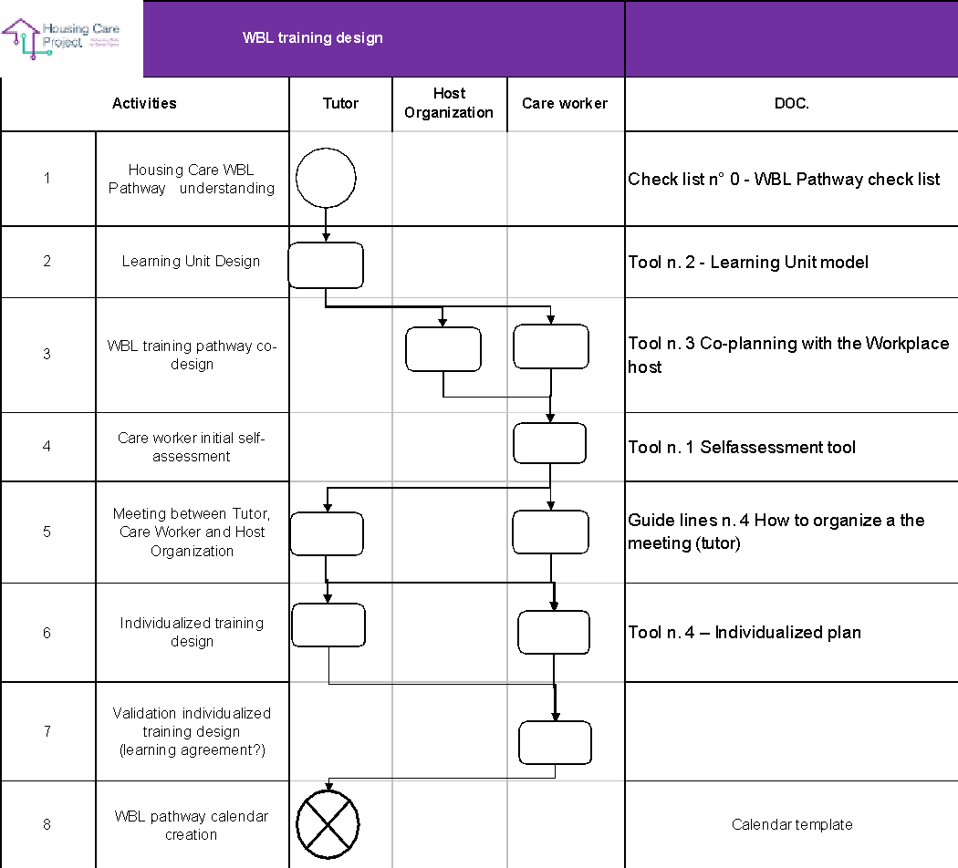

To find a downloadable and editable version of this chart please CLICK HERE

Process activities description

1 | The tutor studies and learns in depth the activities that have to be done to launch and manage the Housing Care WBL Pathway
2 | The tutor should take into account the designed macro-learning unit
3 | The tutor must contact the host organisation asking for a meeting (in person or online)  During the meeting, the tutor should ask the host organisation for a short description of the senior/s, needs, and regarding the available technologies.  The tutor has to co-individuate with the host organisation, the WBL activities/experiences that are consistent with the Housing Care training pathway. For each WBL activity/experience the tutor should define the expected Performance.  Then the tutor can connect the shared WBL activities/experiences with the expected Learning outcomes defined in the Macro Learning Unit  At the end the tutor needs to ask the host organisation if there are some specific rules or law related to the safety and security dimension
4 | The tutor invites the care worker to do the self-assessment. The care worker does it autonomously
5 | The tutor organises a meeting (in-person or online) with the host organisation and the care worker aimed at co-defining the terms of the WBL pathway
6 | The tutor, based on the type of care worker, individualises her/his WBL learning pathway
7 | The care worker accepts and validates the individualised learning plan
8 | The tutor co-defines with the care worker the calendar for the WBL pathway. It can be 7 weeks or 4 weeks long

Management and monitoring process

The flow chart
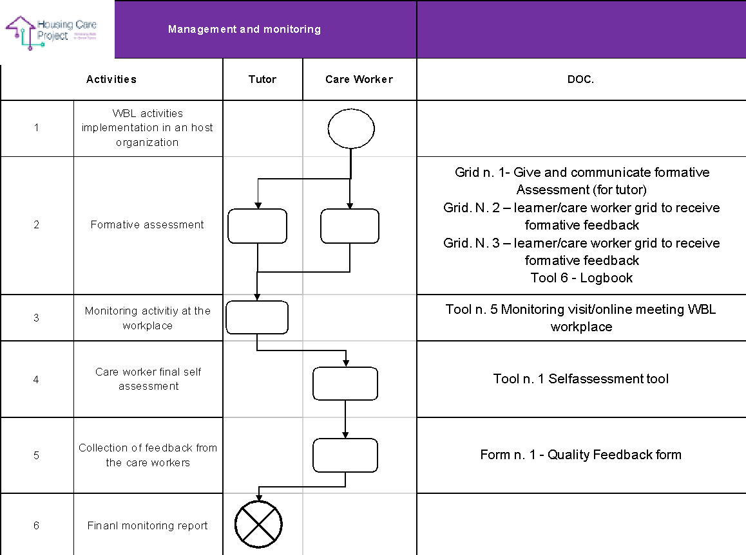

To find a downloadable and editable version of this chart please CLICK HERE

Process activities description
1 | Plan the daily schedule for working on the Housing Care Project.  Analysing the tools, clients, time available e.g. smartphone, tablet, smart TV, age and ability of client, and how much time is available with each client. Identify client interests to tailor activity.  Identify any additional tools or training that may be required.
2 | TUTOR - explain to the care worker what the formative assessment will involve and what is required from them. Reference back to Guidelines and MOOC where possible (as information is already there and they have already completed learning). Reflection and discussion with the tutor and care worker are very important, identify any area which may need to be reviewed, other ways the tutor can help the care worker learn.  CARE WORKER - Reflection and discussion will help identify any area which may need to be reviewed and other ways in which to learn. Option to link in with a tutor at any time with queries,or concerns.
3 | TUTOR - Learner Log to note any queries as they arise, online or paper-based option. Group discussions via online Zoom, WhatsApp etc
4 | TUTOR - Invite the care worker to do the final self-assessment questionnaire.  CARE WORKER - Does the final self-assessment questionnaire
5 | TUTOR - Invite the care worker to do the Quality feedback form.  CARE WORKER - Does the Quality feedback form
6 | TUTOR - Does the final report where he or she describes quantitative data and qualitative information related to the implemented WBL pathway

WBL Pathway checklist

In order to ensure that the tutors implement the tutoring processes correctly while maintaining the shared standard, a checklist was created. Using it, the tutors will be able to:
- develop a systemic awareness of the activities to be implemented;
- know every single activity;
- implement every planned activity;
- check if some activities have not been implemented.

Check list n° 0 - WBL Pathway check list
ACTIVITY | TICK | DATE | SIGNATURE
Before WBL Activities
1. You have promoted the WBL programs for the involvement of the host organisations and you acquired the availability of some of them
2. You have contacted the Care Workers that participated in the MOOC and you have proposed her/him to do the Self Assessment tool
3. You have contacted the Care Workers that have done the Self-Assessment tool in order to understand if they know an available host organisation/family
4. You have matched the care workers that don’t have an available host organisation with an available host organisation
5. You created the calendar of the WBL pathway related to a single care-worker
6. You launched the WBL pathway
During WBL activities
1. You have met the host organisation and the care worker to co-plan the WBL pathway starting from the learning outcomes
2. You have met the care worker to design the individualised WBL pathway
3. You have shared with the care worker and with the host organisation the WBL pathway calendar (30 hours)
4. You launched the WBL pathway
5. You have monitored the care worker’s WBL learning activities during the WBL pathway through an in-person or online meeting and on the basis of the management and monitoring plan
6. You have communicated the monitoring activities to the interested parties (the responsible project partner staff, learner/care worker...)
7. You have completed the formative assessment
8. You have the evidence the care worker has ended the WBL pathway
9. You have done the monitoring report with the most important information acquired during the monitoring meeting
10. You have asked the Care Workers to do the final Self-Assessment tool
ACTIVITY | TICK | DATE | SIGNATURE
After WBL activities
1. You have evaluated the need for modification, correction, remodulation of the path and, if necessary, have modified, corrected, and reshaped the path
2. You have reported the progress of the WBL pathway to the learner/care worker
3. You have prepared a final monitoring report (comment on the results)
4. You have ensured that the care workers have received the certificate of competence

The tasks of the tutors are outlined below in some frameworks. They could be helpful as alternative tools to the checklist above. Their main quality is they provide an overview of the tasks to be performed by the tutors.

Here there is the editable version of the next frameworks
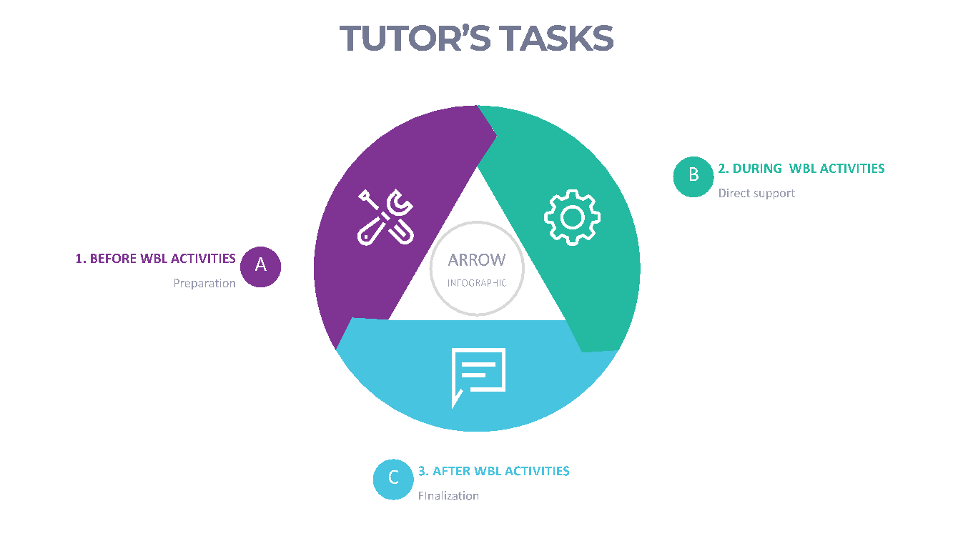
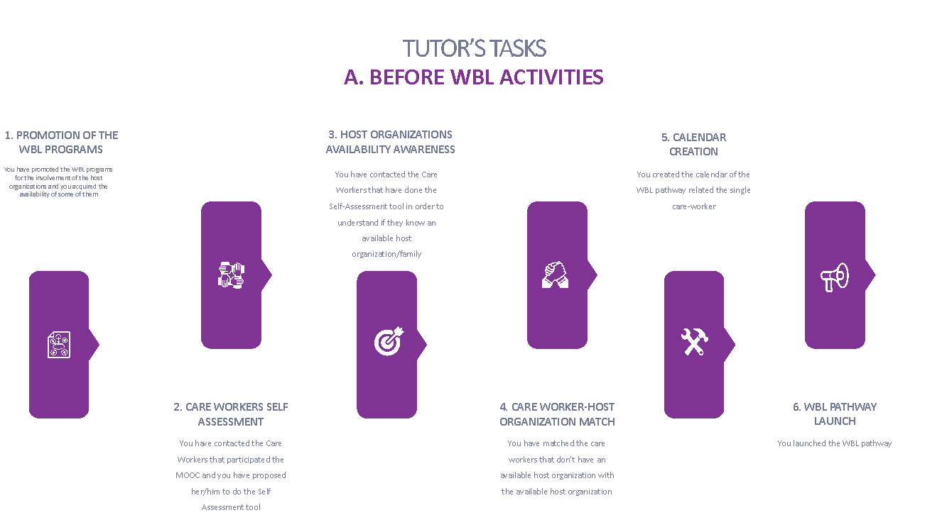
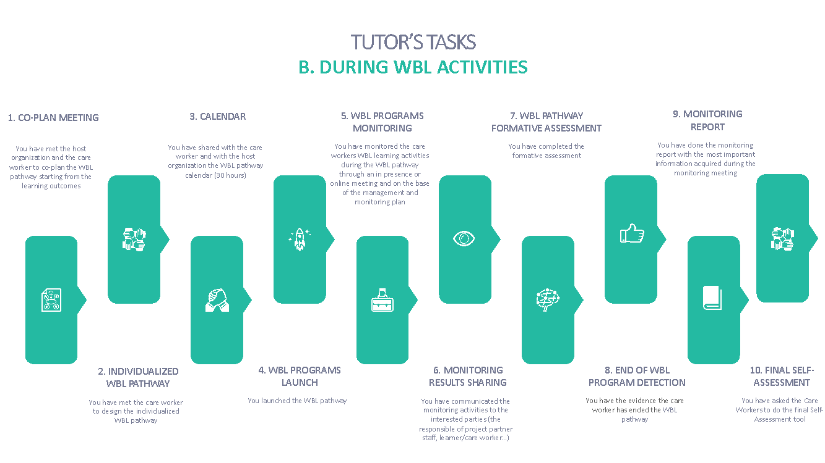
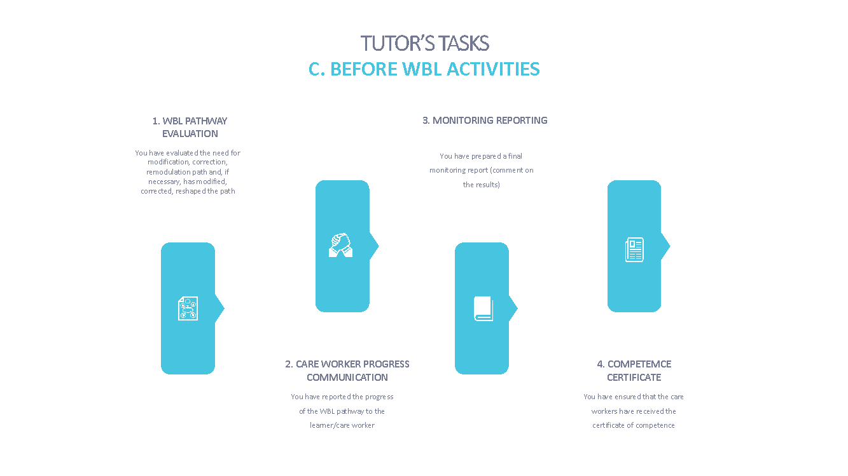

| PLANNING
Resp. Ilmiolavoro

The first step to design the Work Based Learning pathway concerns the planning. It includes the design of the learning unit at the base of the WBL pathways, the co-design with the host organisation and the care worker personalisation of the pathway.
Before dealing with the design of the learning unit, a specific guide on how to describe the learning outcomes is presented.

Guidelines 1 - Writing learning outcomes

Use active verbs
You should ensure that in the formulation of learning outcomes, you use active verbs.
- Indicate what the verb refers to, ie the object of the verb
- You should provide an indication of what the knowledge / skills / competencies and the type of performance are related to.
- Complete with an indication of the context, ie the aim of the application

Correct | Not Correct
Example: the learner/care worker will be able to prepare (verb) the documentation (object) for monitoring the interventions (context) | the learner/care worker knows (what does “he knows” mean? How will you evaluate the "knowledge"?) The documentation procedures (the context is missing)
Example: the learner/care worker will be able to plan all the necessary operations to organise the transport of goods / products | organisational problems have been identified. The learner/care worker is able to manage (how will you evaluate the management?) the organisational procedures
Example: the learner/care worker will be able to create, develop and close the file / procedure of the software used for managing relationships with suppliers | the learner/care worker will be able to manage relationships with suppliers
Example: the learner/care worker will be able to take into consideration the legislation and regulations governing cross-border trade | the learner/care worker will be able to manage the regulations

A useful tool to identify learning outcomes is the Structure of Observed Learning Outcomes which provides a systematic way to describe how a learner/care worker's performance grows in complexity when mastering many tasks. It is a useful framework to create appropriate learning outcomes with respect to the desired quantity and quality of learning in particular phases of the WBL path.
S.O.L.O. Taxonomy represents learning through five levels of increasing complexity, from quantitative (the acquisition of increasing amounts of information) to qualitative (change in understanding and creation of meaning from information).

Tab. 1 - S.O.L.O. Taxonomy
Learning levels | Learning kind features | Verbs examples to describe the learning outcomes associated with the correspondent level
Unstructured | - Simple connections  - Focus on one aspect  - Information still has little meaning | Memorising, identifying, recognising, counting, defining, drawing, finding, labeling, matching, naming, quoting, remembering, reciting, ordering, telling, writing, imitating
Multistructural | - Some connections made  - Focus on different aspects  - Meta-connections (between missing connections) are treated additively  - Partial disorganisation of related concepts  - The meaning of the parts related to the whole is missing | .  Classify, combine, describe, list, report, discuss, illustrate, select, narrate, calculate, outline, put in sequence (order)
Relational | - Some meta-connections are made  - Understanding and integration of the meaning of the parts with each other and to the whole | To apply theory (to its domain ie to use model / procedure), integrate, analyse, argue, choose, conclude, summarise, discuss, plan, characterise, compare / compare, contrast, differentiate, organise, discuss, create a case, build, review and rewrite, examine, translate, solve a problem
Abstract  Extended | Connections with other information of the school subject, between school subjects, and even beyond the WBL training program  - Generalisation and abstraction of underlying principles and hypotheses  - Transfer to new experiences and unexpected problems | To theorise, to hypothesise, to generalise, to reflect critically, to generate, to create, to compose, to invent / to invent, to originate, to try from the pivotal principles (to experiment), to justify, to create an original case, to transfer the theory (in a new domain), to evaluate, to interpret, predict, criticise, reason.

Checklist n. 1 to set up learning outcomes 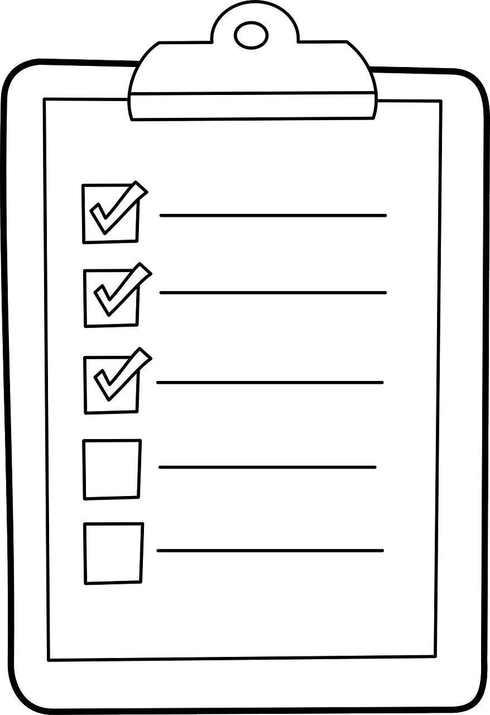
The identification of learning outcomes is a process that requires effort and time. It is not easy to write them well the first time and it may be necessary to review them while developing teaching, learning and evaluation strategies.

Useful directions could come from learner/care worker and workplace tutors:
✓ Does the learner/care worker understand what is expected from her / him?
✓ Is the tutor clearly aware of what the learner/care worker needs to demonstrate in relation to specific learning outcomes?

- Each learning outcome should be written on a basic level, not what you would expect from the highest possible level. The definition of the evaluation criteria and the levels of mastery must be specified in the Evaluation section.
- Make sure that they are expressed at the appropriate level (Taxonomies are a great help).
- Ensure that the learning outcomes refer to the overall learning outcomes of the WBL path.
- Ask yourself if the learning outcomes can be evaluated
- Establish which learning outcomes are essential, useful and optional.
- Ask yourself how the tutor will know if a learner/care worker has reached them, if the method and the assessment criteria are possible

Suggestions |  | Solutions
This learning outcome is public and observable | ☐ | If not, choose a different verb and repeat the question
You are able to understand when the learning outcome be fulfilled | ☐ | If this question causes confusion, chose a different verb and repeat the question
The learner/care worker will understand what to do in order to demonstrate having fulfilled the Learning Objectives or Outcome | ☐
You can identify proof/evidence of the achievement of this learning outcome? | ☐ | If you are not able to make a reliable inference, choose a different verb and repeat the question.
You can identify behaviours and attitudes, to be associated with someone who has achieved this learning outcome? | ☐ | If these aspects are not evident in the learning outcome, choose a different verb and repeat the question.

In the formulation of learning outcomes, it would be advisable to avoid.
Guidelines n. 2 – What to avoid in the formulation of learning outcomes

- Evaluation criteria words such as "good" and "adequate"
- Ambiguous verbs such as "understanding", "knowing", "being aware" and "appreciating". What level of "understanding" do we mean?
- An educational jargon, as for co-planning it is necessary that both students and company tutors understand what it is meant;
- References to the process by which learning takes place, for example "undertaking a project" refers to two learning outcomes "planning a project" and "implementing a project".
- Long lists of separate learning outcomes which are just variations of the same learning outcome.
- Learning outcomes that cannot be easily assessed by referring to specific information in learning outcomes, such as particular theories and techniques. These are included as content.
- Too broad or too specific learning outcomes (they will be inaccessible).

Guidelines n. 3 Planning of a WBL Learning Unit

STEP1 - Definition of the learning outcomes for the WBL pathway
Building meaningful statements on learning outcomes will also help you design meaningful and engaging assessment tasks. If the learning outcomes are designed in such a way as to indicate what the learner/care worker will have to demonstrate at the end of the WBL pathway, it is easier to determine assessment tasks that allow the learner/care worker to demonstrate their knowledge, skills, attitudes, competences.
Include low-level and high-level learning outcomes
The WBL pathway should include a combination of low-level, medium-level and high-level learning outcomes.
If all learning outcomes are low-level, the learner/care worker won’t probably learn much and demotivation will grow.
If all of them are high-level, it is probably too demanding, and the learner/care worker won’t be able to learn what they need to achieve high learning outcomes.
And if they are all of a medium level, the WBL path is likely to be of little significance for the learner/care worker and for all other stakeholders (primarily organisational host, tutor etc).

Example
Learning outcomes:
The learner/care worker will be able to:
- detect and analyse the senior situation in order to understand the main care needs;
- design an individual intervention by applying knowledge of available technologies and Apps;
- select the appropriate technologies and App based on the need analysis carried out;
- apply and use the technologies and Apps in the care and support service provided to the senior;

STEP2: Alignment of the learning outcomes to WBL expected Competences (final) (Optional)
The WBL pathway may take into consideration additional competences with respect to the acquired knowledge through the MOOC.
Example
Learning outcomes:
The learner/care worker will be able to:
- detect and analyse the senior situation in order to understand the main care needs;
- design an individual intervention by applying knowledge of available technologies and App;
- select the appropriate technologies and Apps based on the need analysis carried out;
- apply and use the technologies and Apps in the care and support service provided to the senior;

In defining learning outcomes it may be useful to proceed backward along the S.O.L.O (or other Taxonomy) Taxonomy: from the highest level to the lower levels.

STEP 3: Alignment learning activities to learning outcomes

Defining learning activities will help the learner/care worker to reach each learning outcomes of the WBL pathway.

Example (proceeding with an example taken from Step 1). In the example below we point out the learning outcomes that could be more difficult as the most complex.
Learning outcome N.1:
The learner/worker will be able to:
- detect and analyse the senior situation in order to understand the main care needs;
- design an individual intervention by applying knowledge of available technologies and App;

Learning activities
- Based on the case studies learned through the MOOC, the learner/care worker detects the relevant information from the senior or from the family members, defines what are the main needs and creates the proper combination of technologies and Apps to use during the provided care service;
- Meeting with the tutor during which the learner/care worker verify if the accuracy of the needs analysis and the pertinence of the proposed service technologies

STEP4: Alignment of the assessment to Learning Outcomes

For each learning outcome of the WBL pathway, define how the learner/worker will be assessed, which are the assessment task and the supporting evidence.
The assessment task will answer the question: will the learner/worker be assessed, on what?
The evidence will answer the questions: what do we expect from the learner/worker as proof/ demonstration that they have achieved that learning outcome?
In the description of the assessment task, we should make sure that it is aligned to the teaching and learning activities (if they are well aligned to the learning outcome, STEP 3, support us to guarantee a valid assessment)

Example (proceeding with an example taken from Step 3)
Learning outcomes:

The learner/worker will be able to:

- apply and use the technologies and Apps in the care and support service provided to the senior;

Learning activities

- activities related to the provision of care and support services to the senior using technologies and Apps.
- meeting between the learner/care worker and a member of the family where the learner verifies the perceived effectiveness of the provided service to the senior.

Assessment task
1) Reflection on the service provided by making explicit the performed steps (analysis, service design, service supply, self-evaluation) motivating the choices made.

Evidence
- Critical reflection sheet on the service provided using the human digit approach

Here we can evaluate
❏ the process: reflection board (is the learner/care worker able to evaluate what she/he has provided? Is she/he able to critically evaluate it? Can she/he explain how it’s going on and why is it going on in a certain way?)
o Service

The definition of the assessment task represents the first essential step for the learning assessment.
Below is an easy-to-use grid for the schematisation of the 4 steps of the design aligned to the learning outcomes.

Grid n. 0 WBL design grid - 4 steps

To align Learning Outcomes (LO), Competencies, Learning Tasks (LT), Assessment Tasks (AT)

STEP 1 | STEP 2 | STEP 3 | STEP 4
WBL pathway learning :  At the end of the WBL pathway the learner/care worker will be able to | Alignment of WBL learning outcomes to the targeted / expected competences of the WBL and to the Outgoing competencees | Work Based Learning activities | Evidence evaluation
1 |  | 1 | 1
2 |  | 2 | 2
3 |  | 3 | 3
Etc…

The learning outcomes, the competences, the learning tasks and the assessment tasks, thus aligned, will merge into the Learning Unit.
Tool n. 2 Learning Unit template

Learning unit
title
Service Performance | Report the service performance the learner/care worker has to provide
Measurable and specific learning Outcomes | Report learning outcomes (step 1)
Targeted and Expected Competences aligned to learning outcomes | Report the targeted and expected Competences aligned to learning outcomes (step 2)
Work-Based Learning Experiences | Report the main learning activities (step 3)
Monitoring | Plan and monitoring tools (see monitoring paragraph 3.3)
Assessment  What will be assessed has already been partly defined in the learning outcomes | Report assessment tasks step 4 and refer to steps and tools (see Assessment paragraph 3.4)

Co-designing with the host organisation
As it is well known, the planning of the WBL pathway must be developed with the active involvement of the host organisation (family, healthcare home etc). In order to facilitate and to standardise the co-planning process, a tool has been created to identify:
- the main activities which the learner/care worker will carry out;
- what the learner/care worker will have to prove to be able to do at the end of the learning pathway;
- “translate” learning outcomes indicated by the host organisation into training standards;
- the evidence related to each learning outcome.

Tool n. 3 WBL Co-design with the hosting organization

SECTION 1
Host Organisation: |  | Location:
Contact Person: |  | Contact Phone:
Email Address:

Type of host organisation
☐ Seniors alone ☐ Seniors in a family ☐ Socio-medical residence ☐ Technology company ☐ Other:

Area(s) in which the learner/care worker would focus during WBL
☐ Material care and support
☐ Health care
☐ Other __________________________.
SECTION 2

Content of the WBL activities:
Indicate the main activities (3/4 no more) in which the learner/care worker can be involved, what he/she has to be able to know/ to do for each activity (LEARNING OUTCOMES), what he has to produce (OUTPUT) to demonstrate it.
MAIN ACTIVITIES IN WHICH THE LERNER/CARE WORKER WILL BE INVOLVED | LEARNING OUTCOMES |  | OUTPUT/PERFORMANCE
Prerequisites professional skills, knowledge and personal competences requested before WBL path starting
Regulations |  | Safety and laws

Contact between the learner/care worker and the host organisation before the start of the WBL pathway

As it is well known, the preparatory activities are functional to increase the learner/care worker's level of awareness about the learning experience that will be carried out. For the learner/care worker it is a way to activate and define the expected learning outcomes. For this purpose, some useful activities are described below.

Organise a meeting with the host organisation

This tool is for use by the tutor to organise a meeting with the host organisation:
- at the workplace;
- on-line.

The meeting is an activity in which the learner/care worker has the opportunity to get to know the workplace, get to know the host organisation, meet the senior, ask questions and observe work in progress. It should take place for one learner/care worker and it should involve preliminary preparation. All meetings with the host organisations should include structured activities before, during and after the experience.

Follow some Guidelines the tutor should use to organise an effective meeting.

Guide lines n. 4 How to organise a the meeting (tutor)

Before the meeting
- Evaluate how the study visit can help you to achieve your tutor objectives. Make sure that the meeting will help the learner/care worker understand the context in which they will be challenged, acting as a valuable tool for applying academic concepts learned through the MOOC to real work situations.
- Select a suitable host organisation for the work-based learning experience. Make sure they are appropriate organisations able to link academic learning acquired through the MOOC to the world of work.
- Organise in detail the logistical part of the visit
- Prepare learner/care worker to best maximise their learning:
- Discuss with them their expectations about the meeting they are about to accomplish and what they expect to learn
- Ask the learner/care worker to prepare a list of learning questions and goals they would like to accomplish during the meeting.
- Suggest the following questions to the learners/care workers that they could use during the meeting:
  - What are the main needs of the senior I have to support?
  - What are the tasks that I will have to accomplish during my experience?
  - What is the most important thing to learn for me as soon as I start working here?
  - When I finish my WBL experience here, what do you hope I will have learned/I’ll be able to do?

During the meeting
- Ensure that learners/care workers receive information on the learning activities she/he can do in the context of the host organisation.
- Ensure that learners/care workers receive safety instructions at the workplace.
- Make sure that learners/care workers come into contact with all aspects / environments of the host organisation.

After the meeting
- Help learners/care workers understand and determine the next steps of learning their pathway. The meeting allows learners/care workers to discover further elements for the development of their careers.
- Use the host organisations and learners/care workers feedback for continuous improvement of study visit organisation

Creation of individual WBL pathway (PLAN)

Below is the tool that allows you to draw up a work-based learning pathway in an individualised or personalised way. The information you have to put in the tool is situated in different sources.

Tool n. 4 – Individualized plan

Name surname of the learners/care workers
Learners’ talents and passions
What activities do you like doing? (Think of those activities that, when you do them, you feel psychological well-being. They are not tiring activities for you).
What are your talents? (Think of those activities that you always do well. You always get good results. You don’t need to put a lot of effort into doing them, you have innate abilities to do them).

Individualised learning outcomes
(in line with the content you put on the Tool n. 3 Co-planning with the host organisation you can choose the learning outcomes that fit with the profile of the care worker as an individual)
Planned activities in the host organization - co-planning grid
(in line with the content you put on the Tool n. 3 Co-planning with the host organization you can choose the activities that fit with the profile of the care worker as an individual)

Creation of a WBL Pathway Calendar
Resp. ilmiolavoro srl

Below there are two templates of the calendar you have to create for each single care worker.
The first template refers to a 4-week calendar, the second to a 7-week calendar.
In both scenarios, the duration of the WBL pathway is 30 hours.
After the calendar templates, there are also two calendar frameworks. These are, of course, flexible.

4 week -long calendar hypothesis (preferred)

Name and surname care worker ___________________________________
Name and surname tutor _____________________________________
WBL Pathway from ___/___/2023 to ___/___/2023
Date | Hours | Notes
___/___/2023 | 4
___/___/2023 | 4
___/___/2023 | 4
___/___/2023 | 3
___/___/2023 | 0,5 | Formative assessment
___/___/2023 | 4
___/___/2023 | 3
___/___/2023 | 0,5 | Monitoring
___/___/2023 | 4
___/___/2023 | 3
Total | 30

7 week-long calendar hypothesis

Name and surname care worker ___________________________________
Name and surname tutor _____________________________________
WBL Pathway from ___/___/2023 to ___/___/2023
Date | Hours | Notes
___/___/2023 | 2
___/___/2023 | 2
___/___/2023 | 2
___/___/2023 | 2
___/___/2023 | 0,5 | Formative assessment
___/___/2023 | 2
___/___/2023 | 2
___/___/2023 | 2
___/___/2023 | 2
___/___/2023 | 0,5 | Monitoring
___/___/2023 | 2
___/___/2023 | 2
___/___/2023 | 0,5 | Formative assessment
___/___/2023 | 2
___/___/2023 | 2
___/___/2023 | 2
___/___/2023 | 2
___/___/2023 | 0,5
Total | 30

4-week calendar template (preferred)

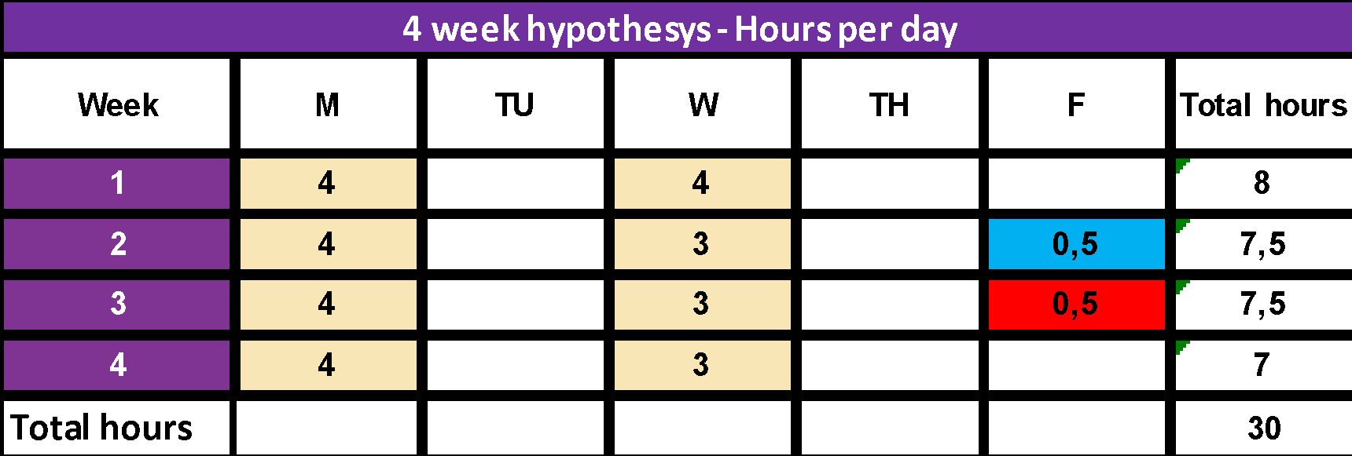

7-weeks calendar framework

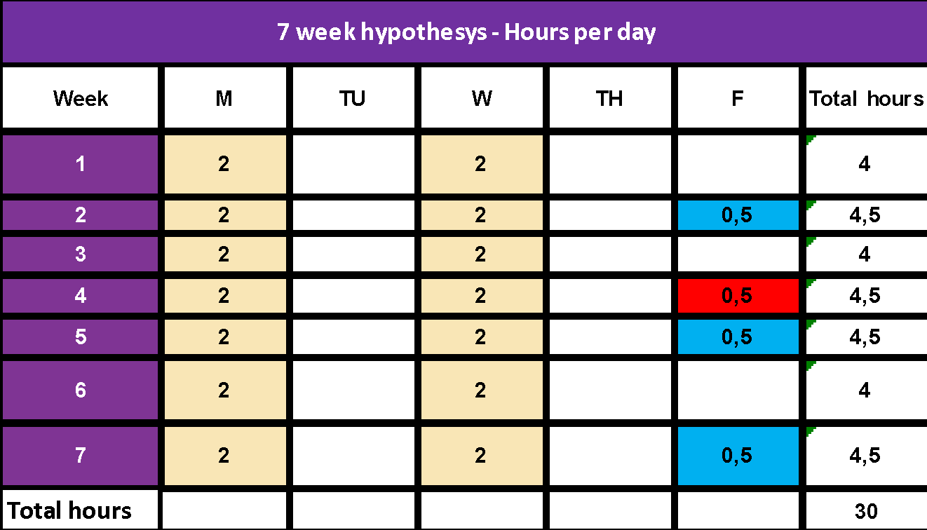

To find a downloadable and editable version of these calendar charts please CLICK HERE

MANAGEMENT AND MONITORING PLAN FOR THE WBL PATHWAYS IMPLEMENTATION
Resp. Ageing Lab

The management of the WBL pathways involves monitoring the activities carried out, the learning outcomes achieved and the ability to manage and resolve critical issues that may occur.

Communication between the WBL tutors and the care workers ensures that learning is linked to the standards and supports the students' learning objectives.

Monitoring ensures safe, quality learning experiences that comply with WBL policies.

- The monitoring plan is developed for each learner/care worker
- The monitoring activity can be done through a meeting between the tutor and the learner/care worker. The tutor can organise the meeting in two ways:
  - In person at the workplace, it means a visit;
  - On-line in the workplace, it means a video-call.

- Some key monitoring guidelines include the following:
  - The timing of monitoring visits and other check-ins by phone or email depends on the length of the work-based learning experience.
  - Conduct a monitoring site visit as least once every grading period. The following schedule is suggested:
    - One visit with the Care Worker at the beginning of the WBL
    - One early conversation (online or in-person) with the Care Worker at the middle of WBL.
    - One visit at the final stages of the WBL.

During the meeting, the tutor should use the following Tool. In this tool, you will find a section related to the development and performance of the care worker. Explanations of these sections are presented here:

- Learner/care worker’s General Performance: The performance of the care worker will be measured on the basis of subjective motivation (of the care worker him/herself) and subjective motivation as perceived by the tutors based on questions and comments made. Some questions that you can ask regarding this topic are:
  - Do you think that this WBL provides you with useful knowledge for your work?
  - How much time do you spend every day practicing the things learned on this WBL?
  - What motivates you to learn more about the suggested technology and health care?
  - Which activities up until now did you enjoy most?
  - What are some achievements you’re proud of?
  - Until now, how would you evaluate the overall learning experience you had with this WBL?

- Activities and tasks advanced: In this part, we want to observe what kind of activities the learners have carried out between the beginning of the WBL and the moment of the monitoring in order to assess their motivation. Therefore, we are going to ask about the following activities or tasks
  - What kind of technology you used, that was included in the course Mooc?
  - What kind of activities and practical exercises that are included in the course Mooc have you carried out?

- Pending activities and tasks: This section aims to observe what kind of applications, technologies, activities and tasks have not been carried out up to the moment of the evaluation, why (not in line with reality, lack of time, too difficult... for example). This will make it easier to see what is missing to reach the final objective.

- Difficulties: It is very important to know what difficulties the care workers have faced during the development of the WBL, and what can be done to solve them. Some questions you can use in this section are:

  - Have you encountered any difficulties during your apprenticeship at the WBL so far?
  - What kind of difficulties have you encountered in carrying out the activities of the WBL?
  - Were these difficulties more related to technology, lack of information, or lack of time...?

- Recommendations from learner/care worker: Based on their own experience and the last questions mentioned, is important to know their thoughts and ideas about the quality and development of this WBL.

- Recommendations from the WBL tutor: In the same way, the experience of all WBL tutors is important in order to make the right modifications and to be sure of the correct development and progress of the worker in his or her learning. In this part, you should develop your own personal and professional idea, based on the answer given by the care workers.

- Commitment to follow-up: Commitment to follow-through means that we are prepared to implement the tasks and activities learned and that we can do so with determination.

Tool n. 5 Monitoring visit/online meeting WBL workplace
GUIDE: the tool can be used to check the progress of the learning path in the workplace. The tutor verifies both the progress of Learning outcomes and the activities carried out (Tasks and activities). This monitoring activity must be done through questioning and observation or through an interview addressed to the learner/care worker.

Monitoring Tool visit (online or in-person) WBL Workplace
Learner/Care Worker:

WBL tutor | Date and time
☐ Learner/care worker observed performing the task

☐ Meeting with the Learner/care worker
Area covered by the visit | Revision and Comments
Learner/care worker’s General Performance
Activities and tasks advanced

Pending activities and tasks
Difficulties
Recommendations from learner/care worker

Recommendations from the WBL tutor

Commitment to follow up

Next monitoring meeting

Form n. 1 - Quality Feedback form

WBL quality assessment
Please rate the following aspects of the WBL using a rating scale from 1 to 4:
1 Strongly Disagree, 2 Disagree, 3 Agree, 4 Strongly Agree
1 | The structure and teaching programme planned for the WBL were appropriate. |  |  | 1 |  | 2 |  | 3 | 4
2 | The contents of the course have been adjusted to my training needs. |  |  | 1 |  | 2 |  | 3 | 4
3 | There has been an appropriate mix of theory and practical application |  |  | 1 |  | 2 |  | 3 | 4
4 | The duration of the WBL was sufficient according to the objectives and contents included |  |  | 1 |  | 2 |  | 3 | 4
5 | The delivery of the WBL is useful and has facilitated learning.r |  |  | 1 |  | 2 |  | 3 | 4
6 | The methodology used has been the most appropriate to the objectives and contents of the course |  |  | 1 |  | 2 |  | 3 | 4
7 | I have had sufficient means of support (individualised tutorials, mail and mailing lists…) |  |  | 1 |  | 2 |  | 3 | 4
8 | The WBL has allowed me to acquire new skills/capacities that I can apply to the job |  |  | 1 |  | 2 |  | 3 | 4
9 | The WBL expanded my knowledge to advance my professional career. |  |  | 1 |  | 2 |  | 3 | 4
10 | The WBL has helped my personal development. |  |  | 1 |  | 2 |  | 3 | 4
11 | The WBL has met all my expectations |  |  | 1 |  | 2 |  | 3 | 4
12 | The guides, tutorials and teaching materials have made the course easy to follow |  |  | 1 |  | 2 |  | 3 | 4
13 | I have been able to have assessment and self-assessment tests that allow me to know the level of learning achieved throughout the WBL. |  |  | 1 |  | 2 |  | 3 | 4
14 | The quality and quantity of the teaching material included in the WBL have been adequate. |  |  | 1 |  | 2 |  | 3 | 4
15 | Throughout the WBL, I have been able to count on quality teaching support and guidance. |  |  | 1 |  | 2 |  | 3 | 4
16 | Technology included in the WBL is realistic and adapts to the needs of seniors |  |  | 1 |  | 2 |  | 3 | 4
17 | The timing of the proposed WBL and its distribution has been adequate. |  |  | 1 |  | 2 |  | 3 | 4
18 | The knowledge acquired is applicable and/or useful in my job position |  |  | 1 |  | 2 |  | 3 | 4
19 | My tutor was very knowledgeable about the content and was able to transmit the knowledge applied to practice at all times |  |  | 1 |  | 2 |  | 3 | 4
20 | My tutor has provided me with the necessary feedback throughout the WBL to achieve the proposed objectives |  |  | 1 |  | 2 |  | 3 | 4
Please indicate the overall assessment of the WBL
Totally satisfactory |  | unsatisfactory | Regular |  | Satisfactory |  | Totally Satisfactory
1 |  | 2 | 3 |  | 4 |  | 5

What do you think has been the best about the WBL?
What do you think is the worst about the WBL?
What content do you think is missing from this WBL?
How do you think this WBL could be improved?
Briefly summarise what you have gained from this course

LEARNING assessment
Resp. Ageing Lab

The assessment process involves a planning phase and an implementation phase.
For the assessment process, you should use specific tools. In the Housing Care WBL pathways, the focus is more on the formative assessment than on the summative assessment.

The formative assessment is closely linked to the duration of the WBL pathway. In general, it is good practice to provide a couple of moments dedicated to formative assessment during the key steps of the WBL pathway.
Information detected during the formative assessment must then be included in the excel Tool used for monitoring.
Observation grids can be used as tools; reflection grids for tutors and Learner/care worker (grid n. 1, 2 and 3) and other tools already used by the schools.

- Formative assessment
The formative assessment, which aims to map the progress of the learning process, provides useful information on what has already been learned and what is yet to be learned. It is functional in order to review the WBL project in light of the emerged areas of improvement. During the assessment phase, the following must be considered:
- intermediate learning outcomes of the Learner/care worker;
- learning process;
However, as the formative assessment is also useful for tutors to reflect on the WBL project, a specific reflection should be made on the support strategies the tutors can adopt in order to support the Learner/care worker's learning (have a look at the Grid n. 7 below)
The grid can be used by the learner/care worker either in order to reflect on their own learning process, or in order to request feedback from the tutor if there are different results between the self-assessment of the learner/care worker and tutor assessment.
In other words, knowing how the learner/care worker self-represents his learning path, the beliefs regarding what he has learned / has yet to learn, the self-regulation process he intends to activate to fill any gaps, allows tutors to support the student and, if necessary, act in a corrective capacity where there are inconsistencies.
Feedback will be more effective as it is based on a knowledge of what the learner/care worker believes already he has improved or he needs to improve.

Grid n. 1 - Give and communicate formative feedback (for tutors)

Feedback  levels | Questions for further information and to infer new reflection
Learner/care worker outcomes | - Are the results obtained in an activity satisfying the success criteria?  - Are the results of the learner/care worker, correct? Why yes, why not?  - How did the learner/care worker elaborate on the contents of the care service / task?  - What did you appreciate about what the learner/care worker did in terms of care service?  - Where is the error?  - What did the learner/care worker do better?  - What knowledge does the learner/care worker need in order to do better?
Learning process | - What didn’t he do correctly and why?  - What information, contained in the delivery, did he not examine?  - What strategies did he use?  - What justifies the correctness of a job?  - What explanations should be given to justify the correctness of a job?  - What must the student wonder to understand how to do a proper job?  - What relationships are there between the different parts of the task?  - What is the level of understanding of the concepts and knowledge related to the task?
Self assessment  And  Self learning adjustment | - How can the learner/care worker review his work?  - How can the learner/care worker perform systematic checks while performing a task?  - What ideas is the learner/care worker making about the feedback and the indications he receives?  - How can the learner/care worker reflect on his / her learning?  - What did the learner/care worker do for ...?  - What happened when ...?  - What explanation can be given for ...?  - What doubts does the learner/care worker still have about the work to be done?  - How is this task related to ...?  - What do all these indications have in common?  - After examining his work (the answer) what does the learner/care worker think he has learned?  - How has your way of thinking about the problem changed and doing the job?  - Can the learner/care worker teach another student? How and what ...?
Adapted from: Hattie J., (2012). Visible learning for teachers. Maximizing impact on learning, London, Routledge, p. 129

The grid above is used by the tutor to stimulate in the learner/care worker the production of very useful feedback for both them and the learner/care worker learning.
The form can be used by the tutor during the formative assessment sessions or at any time appropriate to promote reflection.

Grid. N. 2 – learner/care worker grid to receive formative feedback

Feedback  levels | Questions for further information and to infer new reflection
Learner/care worker outcomes | - How was it? What did I do well, what did I not?  - What was the goal of the job?  - After some task, what will be the next step?  - What goal can I attain?
Learning process | - How did I "work"?  - What did I miss during the "work"?  - Where and when did I lose control of what I was doing?  - When didn’t I lose control and how did things go?
Self-assessment  And  Self adjustment of learning | - Why did it happen?  - What have I been good at and why?  - Which parts of the procedure should I improve?  - What additional knowledge do I need?

Grid. N. 3 – learner/care worker grid to receive formative feedback

Feedback Levels | Learner/care worker outcomes
Are you satisfied with the results of the activities that you carried out between the last formative feedback and until now to date? | NO |  |  | Maybe |  |  |  | YES
Do you think that your users (seniors) are satisfied with the results of this WBL until now? | NO |  |  | Maybe |  |  |  | YES
In your opinion, how did you feel doing these tasks? | I need more support-training |  | I feel I am doing ok
Do you believe that you are reaching the expected goals? | NO |  |  | Maybe |  |  |  | YES
Do you consider that you are developing the correct skills in order to reach the expected goals? | NO |  |  | Maybe |  |  |  | YES
Do you have problems incorporating technology into your day-to-day work? | NO |  |  | Sometimes |  |  |  | YES
What would you need from now on, to improve and feel more confident in your work through the technology provided?
What type of technology have you found most useful in your job to date?

Feedback Levels | Learning process
Are you keeping a diary of your activities and tasks? | NO |  |  |  |  | YES
Explain briefly the activities that you carried out between the last formative feedback and this.
During this period what kind of technology you used during your job?
In some cases, were you unable to carry out the planned task with the seniors? If yes, briefly explain what happened.
Have you ever felt that the training was getting out of control? | NO |  |  | Maybe |  |  |  | YES
When you lost control, what happened? What did you do to solve it?
Do you think you can carry out the WBL and your work at the same time without interference between them?
Are some kinds of technology that you haven’t used in your job? If yes, Which one and Why?
Feedback Levels | Self-assessment  & Self-adjustment of learning
Does the work-based learning programme provide real-life work experience for Care Workers? | Not at all | slightly |  |  | Moderately |  | something |  |  | Absolutely
Do you think that the technology provided is useful to improve the care/ life of seniors? | Not useful at all |  | Somewhat useful |  |  | Moderately useful |  |  | Very useful
Do you think that the technology provided is useful to improve your work? | Not useful at all |  | Somewhat useful |  |  | Moderately useful |  |  | Very useful
To what extent do you think your understanding of home care technologies has improved through this WBL? | Not improved at all |  | Somewhat improved |  |  | Moderately improved |  |  | Significantly improved
How relevant do you think the content of the WBL is to your work? | Not relevant |  | Somewhat relevant |  |  | Moderately relevant |  |  | Very relevant
During this period, do you feel that you should improve in some skills regarding your job and technology? Explain briefly
Rate yourself with the following skills/abilities
Manage Smartphones/Tablets/Smart TV | Quite poor, I need to improve a lot of things |  |  | Depends, I to need improve just a few things |  |  |  | Very good, I don't need to improve anything.
Tecno-security (online data management, user support...) | Quite poor, I need to improve a lot of things |  |  | Depends, I to need improve just a few things |  |  |  | Very good, I don't need to improve anything.
Management of the different Apps proposed | Quite poor, I need to improve a lot of things |  |  | Depends, I to need improve just a few things |  |  |  | Very good, I don't need to improve anything.
Communication Skills through technology (effective digital communication) | Quite poor, I need to improve a lot of things |  |  | Depends, I to need improve just a few things |  |  |  | Very good, I don't need to improve anything.
Communication Skills (Empathy, active listening…) | Quite poor, I need to improve a lot of things |  |  | Depends, I to need improve just a few things |  |  |  | Very good, I don't need to improve anything.
Time Management | Quite poor, I need to improve a lot of things |  |  | Depends, I to need improve just a few things |  |  |  | Very good, I don't need to improve anything.
Ability to motivate seniors | Quite poor, I need to improve a lot of things |  |  | Depends, I to need improve just a few things |  |  |  | Very good, I don't need to improve anything.
Ability to work with the rest of the team | Quite poor, I need to improve a lot of things |  |  | Depends, I to need improve just a few things |  |  |  | Very good, I don't need to improve anything.
Promoting senior’s autonomy | Quite poor, I need to improve a lot of things |  |  | Depends, I to need improve just a few things |  |  |  | Very good, I don't need to improve anything.

The grid can be used by the learner/care worker accompanying the logbook:
● every day;
● every week;
● at an intermediate time;
● in a final moment.
The answers must be noted by the learner/care worker in the logbook.

Tool 7 Learning journal – logbook
Resp. Ilmiolavoro

Name and Surname | Host organisation

This tool will support you in increasing the value of your work-based learning experience. Using it you will reflect on the main learning results you will get during your day-to-day learning activities.

1. Describe the outcomes and the learning process related to the daily activities in which you have been actively involved (main topic focussed, care services type, training issues addressed, etc.)

Outcomes
- How was it? What did I do well, and what I did not?
- What was the goal of the job?
- After some task, what will be the next step?
- What goal can I give myself?

Learning Process
- How did I "work"?
- What did I miss during the "work"?
- Where and when did I lose control of what I was doing?
- When didn’t I lose control and how things went

- Describe in summary the host organisation (senior, relatives, staff in case of senior home, relationship with the other actors)

- List the main learning results you have gained (knowledge acquired, skills developed during the work-based learning experience etc)
Self-assessment And Self-adjustment of Learning
- Why/how did it happen?
- What have I been good at and why?
- Which parts of the procedure should I improve?
- What additional knowledge do I need?

- List the main un-expected learning results you have gained (knowledge acquired, skills developed during the work-based learning experience etc)
Self-assessment And Self-adjustment of Learning
- Why/how did it happen?
- What have I been good at and why?
- Which parts of the procedure should I improve?
- What additional knowledge do I need?

05

TUTOR TRAINING CURRICULA

| TUTOR TRAINING CURRICULA
Resp. Ilmiolavoro

Table of the contents

1. The context and motivations
2. Work-Based Learning and tutoring skill needs
3. Target group
4. Training objectives and the competence areas
5. Curriculum design
5.1 Learning outcomes
5.2 Learning activities framework and the training units
5.4 Adopted training methods
5.5 Learning assessment
5.6 Certificate

.

1. The context and motivations
The training activity supports the development of Outcome No. 2, a Toolkit containing resources for trainers and practitioners for the development of Human-Digit-Care competencies in a work-based learning context.
The recent Green Paper on Ageing (COM 2021_50) reiterated the need for health care and other services for seniors EU (p. 18). In perspective, resources are scarce, the available workforce is dwindling. Fortunately, many of the technological innovations underpinning Telemedicine (hereafter E-Health), whose deployment has been accelerated by COVID-19 are facilitating the massive 'digital transition' in this sector making it more sustainable for the future. The need for 'spaced' care and assistance has given a strong impetus to the emergence of Housing Care. This is Long-Term Care (LTC) for seniors in autonomous living contexts and/or in sustainable residential forms (co-housing), alternatives to traditional residences for seniors which, while remaining, tend to include the use of technology. Today, Housing Care makes possible healthy ageing based on humanised 'person-centred' care also with the support of technology. This can lead to a change in care needs, with an improvement in the quality of life for the older person and mitigation of the pressure on spending.
Senior Personal Care Workers (hereafter Care Workers) active in senior care, the project's TARGET GROUP (TG), constitute the majority of the long-term care workforce (70%) and have very low entry requirements. There are limited requirements for ICT skills and the use of technological applications (EU, Core Competences of Healthcare Ass., 2016, p. 63). Half of them work at home (OECD, Who cares?,2020, p. 18,). In many EU countries, they are only required to have a minimum level of education. (OECD, idem, p. 14). Between 2018 and 2030, in the Senior Care sector, a strong shift in demand is expected from low to medium-skilled workers (Cedefop, Skillpanorama, 2019). Most technologies are user-friendly, and after COVID-19 more sophisticated Ambient Assisted Living (AAL) devices such as surveillance robots, remote healthcare systems, smart home technologies, E-Health devices (EITHealth, Health Skills,2020) are emerging that do not replace care workers, who play an irreplaceable role in human interaction, but significantly improve care and treatment.
The problem addressed by the Housing Care project is that, in light of the "digitisation" of senior healthcare, employed Care Workers have an inadequate skill set. The risk is their transition to unemployment, with negative impacts on the Senior Care system. A survey carried out by the partners showed that:
- There are many Care Workers who have never used AAL or E-Health technologies;
- Care Workers because of their work have difficulty keeping up to date in these specific skill areas;
- The technologies are many and diverse and evolving very fast, the VET providers partners have difficulty in producing an organic training offer for them and are not dynamically adapted to the changes.
The general objective therefore is to contribute to reduce the risk of TG unemployment and to make the European Senior Care system sustainable.
Some specific objectives of the project are:
- Develop adequate levels of knowledge and skills in the humanised (person-centred) use of AAL or E-Health technologies by Care Workers;
- Adapt the competence structure of care workers to the evolving needs of their work.
As already mentioned, there is a difficulty on the part of the care workers to participate in training activities implemented in a traditional way due to their work commitment. The MOOC constituted a learning context that mainly fostered “knowledge”; however, it is necessary that care workers develop skills in a practical manner and in a humanised way, of technologies for the assistance and care of the seniors.
Work-Based Learning (WBL) is the most effective way of developing skills by applying the knowledge acquired through MOOCs to the work context. In order to achieve these objectives, this Toolkit was created containing resources also for the implementation of work-based learning pathways by care workers. It is necessary to standardise the level of competences of training designers and trainers/tutors so that they can better design and support WBL pathways.

2. Work Based learning and tutoring skill needs
The implementation of the WBL pathways by Senior Care Workers will be possible after the following skill gaps have been filled:
A) CONSTRUCTIVELY ALIGNED TRAINING DESIGN IN A WBL CONTEXT
Training designers have to acquire/share the competences to design Work-Based Learning Units starting from the Learning Outcomes and aligning to them:
- the learning activities;
- the expected competences;
- the assessment tools.
They should also develop:
- the ability to co-design, taking into account the context of the host organisation (home, residence for seniors) in which the work based learning may take place;
- the ability to personalise the WBL pathway on the basis of the personal and professional characteristics of the care workers.

B) WBL TUTORING IN A CVET CONTEXT
Trainers/tutors, in order to support senior care workers in a tutoring logic, will have to develop skills:
- in teaching in the field, in a work-based context;
- in stimulating and inspiring learning,
- in guiding the senior care workers in the processes of self-assessment and self-awareness of the achieved learning, using different types of assessment tools.

C) QUALITY CYCLE IN LINE WITH WBL EQAVET+ PRINCIPLES
Another element that makes the WBL indispensable is the need to design the training pathway according to the four steps of the Quality Cycle, adhering to the descriptors & to the indicators in order to guarantee high quality standards of the EQA-WBL. The WBL pathway will be aligned to the messages in the EQAVET+ Building Blocks.

D) COMPETENCES CERTIFICATION IN LINE WITH THE ECVET FRAMEWORK
Finally, it will be necessary to homogenise the competences of the training designers and trainers/tutors in relation to the ECVET processes. It is aimed at simplifying the validation and recognition of the competences and knowledge related to the care workers' work. ECVET is in fact based on the description of competences in units of learning outcomes, on transfer, recognition and accumulation processes and on a set of used documents (e.g. Learning Agreement).
If the partners' trainers/tutors and training designers don’t develop/share the necessary competences, it will be unlikely to test and evaluate the effectiveness of the care workers' work-based learning pathways in the CVET context.

3. Target group
The target group of the training activities are the training designer and the trainer/tutors belonging the partners organisations that will become WBL tutors. They are the staff members of the partners who designed the MOOC and created the related training content.

4. Training objectives and the competence areas
The LTTA was aimed at promoting the development of competences in the design of training activities in WBL logic and in the support of learning activities as Tutors in the Continuous VET context.
The specialised training contents will enable the staff of the Partners involved to:
- Develop knowledge on technologies connected with the senior care work;
- Develop Human Care Mindset knowledge;
- Develop skills useful for the creation of the two Practical Guides on the use of on Technologies connected with the senior care work and the application of Social-Emotional skills to be included in the toolkit.
- Increase competences needed to design WBL learning units;
- to increase the competences needed to support senior care workers in WBL pathways;
- increase competences needed to design self-learning, assessment tools;
- develop competences on the WBL EQAVET+ and ECVET frameworks;
- establish ways of involving care workers for the pilot test.

The partners’ staff member that participate in the training activities will enrich the following competence areas:
- basic use of technologies for seniors;
- how to create practical guides for care workers as learning tools;
- how to design WBL pathways;
- how to create assessment tools;
- how to support the care workers along the pathways.

5. Curriculum design

5.1 Learning outcomes
At the end of the training, the participants will be able to:
- to create practical guides on the use of technologies for seniors and on the adoption of the human touch
- how to design WBL pathways for senior care workers;
- how to create WBL assessment tools for senior care workers;
- how to support the care workers along the WBL pathways.

5.2 Learning activities framework and the training units
In the LTTA two learning ways are expected:
- face-to-face during which the necessary knowledge will be transferred and the main skills will be developed;
- project work through which the toolkit will be developed.
The training units in the face-to-face pathway are 3. These are followed by the project work units.
The learning units are:
1 | Training Unit 1 – Work Based Learning, processes, design and EQAVET+ principles
1.1 | Topics
1. WBL co-design,
2. Learning outcomes
3. WBL learning unit design
4. Co-designing work-based learning activities
5. Individualising work-based learning paths
6. Checking adequacy in terms of WBL quality
1.2 | Connected Learning Outcomes
At the end of the training, the participants should be able to design WBL pathways for senior care workers
1.3 | Learning experiences-activities
- Conceived WBL toolkit presentation
- Learning outcomes definition and related practical activity in group work
- Learning Unit template presentation
- Practical exercise group work aimed at design a WBL learning unit
- WBL Co-planning and related roleplay activity
- WBL individualisation and roleplay activity
- WBL pathway processes design in group work

2 | Training Unit 2 – WBL monitoring, formative assessment and tutoring
2.1 | Topics
1. tutoring support,
2. dialogue and guidance in learning,
3. formative assessment,
4. reflective self-assessment,
5. tools for abstracting the knowledge and skills developed
6. skills certification and ECVET framework
2.2 | Connected Learning Outcomes
At the end of the training, the participants should be able to support the care workers along the pathways
2.3 | Learning experiences-activities
- tutoring support
- how to organise and lead a meeting with the care workers using presentation and role play
- how to monitor the Work Based Learning progress and how to support the care workers presentation and role play
- formative assessment presentation and exercise
- how to foster meta-cognition of the care workers through the log-book presentation
- the ECVET framework presentation

4 | Training Unit 3 – Project work
4.1 | Rationale
Days 4 and 5 PROJECT WORK Definition of Guide framework and distribution of tasks Sharing - basic framework of the WBL learning units - standard development of the learning units; - tools to be designed; Division of labour between the partners; Definition of validation ways of the training tools and contents; Sharing of the involvement way of the care workers on the pilot test; Evaluation of learningM At the end of the training, experts from partners will provide the participants a 3-months coaching service to support them in the development of the Toolkit (PR2).

4.2 | Topics
1) practical guides
2) learning unit
3) tools
4) task distribution
5) care workers involvement
4.3 | Connected Learning Outcomes
At the end of the training, the participants should be able to:
- create practical guides for care workers as learning tools;
- create assessment tools
4.4 | Learning experiences-activities
Activities implemented in work group:
- presentation of the Practical guides proposal and finalisation of the contents
- presentation of the Self-assessment tool and sharing of all contents
- presentation of the Formative Assessment tool and sharing of all contents
- presentation of the Monitoring tools and sharing of all contents
- co-creation of a WBL pathway management tool for the tutors
Distribution of the tasks to complete all the tools
Sharing of the way to involve the care workers
Co-identification of the timeline for the pilot test of the WBL pathways in each country

5.4 Adopted training methods
The methodology entails both the use of traditional pedagogical techniques and the use of approaches for experiential learning based on case studies and workshop exercises. Training will be practical-oriented. Part of the learning will be facilitated through interaction and dialogue among participants. Particular attention will be paid to the assessment and certification of learning in accordance with EQF principles and ECVET processes.

5.5 Learning assessment
The learning assessment will be based on the observation of products that the learners have created during the LTTA. The final assessment will be reliable, it will be referred mainly to real and appropriate products, which are considered as necessary and sufficient evidence of the target competences. The competences will be appropriately certified taking into account the planned learning outcomes and evaluation results.

5.6 Certificate
The participants will receive a certificate of attendance. They will also receive a Europass Mobility certificate, which describes the whole educational process, the objectives and the learning outcomes of the trainings.
The recognition and validation of the learning outcomes achieved by the participants in the learning activities is ensured by a special procedure that involves the use of a range of tools:
- A Memorandum of Understanding between partners. The Memorandum will define the general cooperation framework and agreements on the acquisition and evaluation of knowledge and skills.
- In a second step, the partner responsible for each international learning activity and other partners will jointly define the learning outcomes (LOs): identification of the LOs units to be acquired during the international learning activity and the modalities by which the LOs are transferred and recognised, including assessment criteria and methods to verify whether the participant has actually achieved the defined LOs. This synergy between sending and hosting partners in terms of assessment procedures and criteria allows a clear understanding of the expected performance level. This synergy will concern the following: content and assessment indicators clearly linked to the LOs; assessment criteria and methods aligned with the LOs and duration of the learning activity; the way in which the participant ́s results are recorded on his/her own Europass Mobility certificate; modalities and responsibilities for evaluation and recognition.
- On the basis of what was mentioned above, the Learning Agreement is then signed by the participant, the sending and the hosting organisations. It will specify which LOs are expected and how they will be assessed.
- This whole preparation phase will be important to guarantee a clear and transparent learning process. For the realisation of the international learning activity, the following activities will be carried out:
o Sending a copy of the Learning Agreement to all participants
o The participants will take part in the international learning activity as defined in the Learning Agreement
o Partner responsible for the international learning activity will identify an internal resource that will be responsible for supervising the entire learning path. He/she will take care of all the documentation for the Europass Mobility after the participants have demonstrated the achievement of the Los based on the assessment process defined in the L.A. and in the MoU.
At the end of the international learning activity, the sending partners will validate and recognise the acquired learning outcomes in the Europass Mobility

06

TRAINING MATERIALS

| TRAINING MATERIALS
Resp. All partners developed part of the project result n. 2

In order to implement the previous curricula, some training materials were developed. These are in the form of presentations that describe pieces of knowledge and and how to organise the practical activities and exercises.
Here follow a list of the training materials available to project website:
https://housingcare.net/

- presentation on:
  - toolkit framework description
  - how to design a learning unit
  - how to individualise a WBL pathway
- presentation on co-plan a WBL pathway
- presentation on practical guide n. 1 (technologies)
- presentation on practical guide n. 2 (human touch)
  - Module 1
  - Module 2
  - Module 3
  - Guide for trainers
  - Tips and tricks
  - Appendix - Exercises
- presentation on monitoring and formative assessment
- presentation on Housing Care Mooc

07
EQAVET+ guidelines

| 7. EQAVET+ guidelines
Resp. Ilmiolavoro srl supported by all partners

The reference
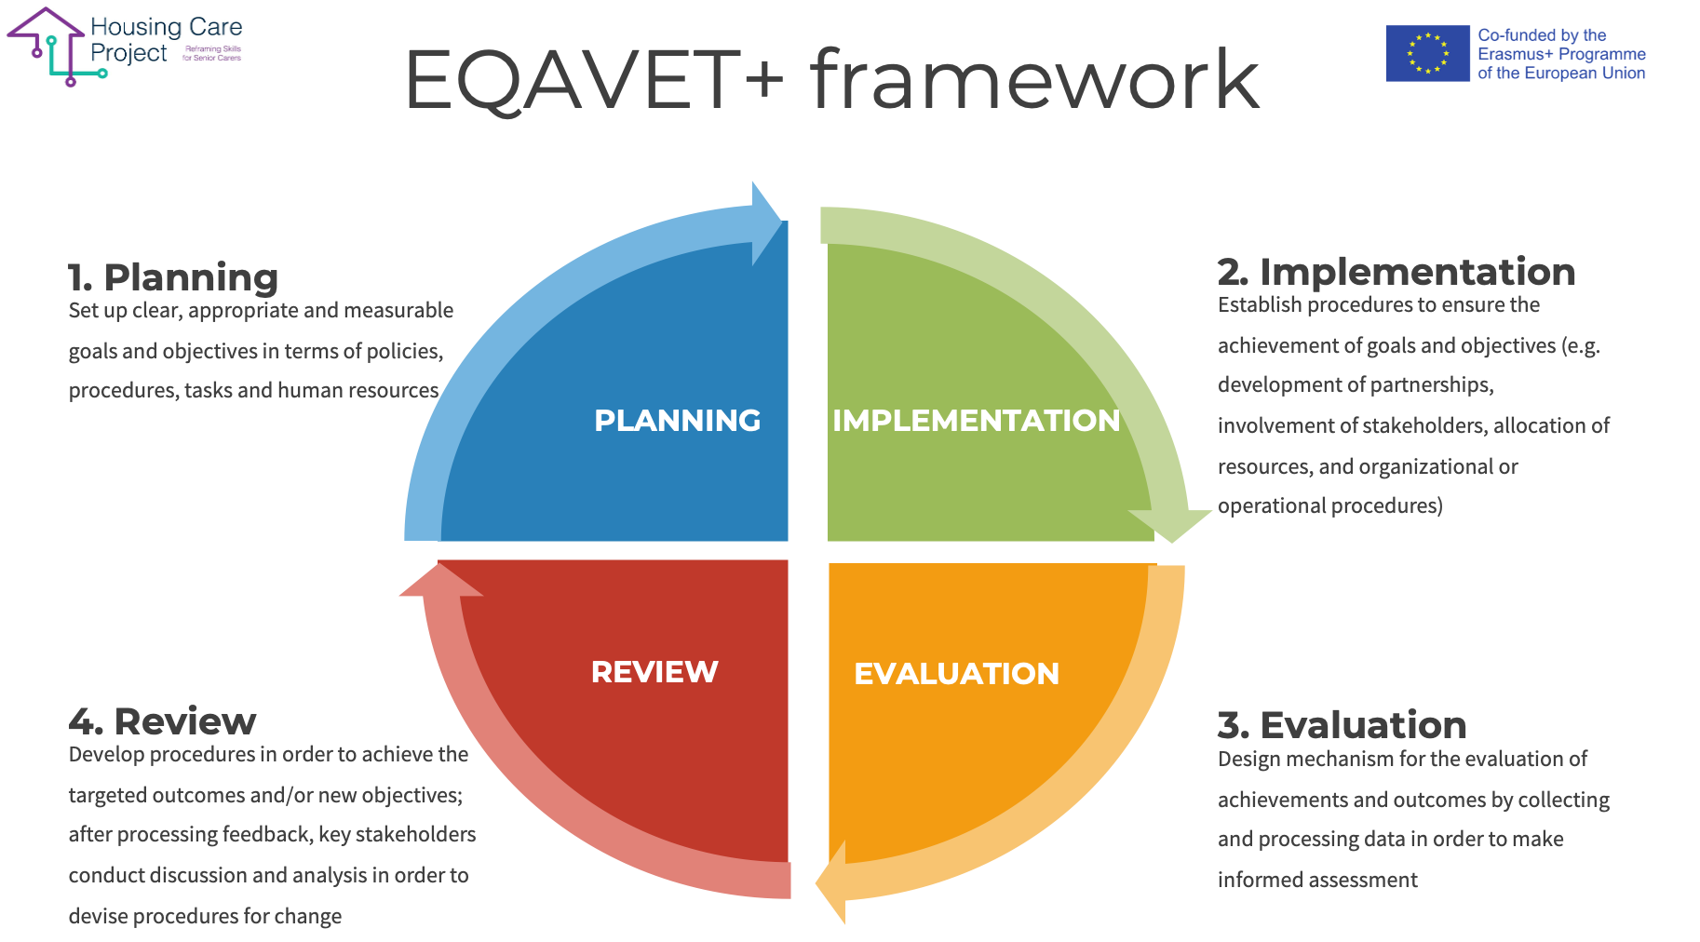

Editable graphic

Guidelines on Quality Assessment and Self-Assessment in line with the updated EQAVET+ framework

In order to implement quality procedures before, during and after the WBL pathway, we have prepared the following checklist with the aim of helping anyone - with a responsibility in the coordinating and in the guidance of WBL pathways - to carry out the activities required.

The checklist should be used by the workplace tutor: every time one of the planned activities is completed, the tutor can put a check mark, insert the date and sign. This tool will also allow one to check if something hasn’t been carried out or has not been carried out after the deadline.

Checklist n 2 EQAVET procedures before, during, and after the WBL

ACTIVITY | TICK | DATE | SIGNATURE
Before WBL Activities
You have promoted the WBL programs for the involvement of the host subjects | ☐
You have acquired the availability from the host subjects to host organisation/family visits | ☐
You have developed a WBL pathway starting from the learning outcomes | ☐
You have developed one or more Learning Units starting from the learning outcomes | ☐
ACTIVITY | TICK | DATE | SIGNATURE
During WBL activities
You have prepared the learners/care workers for the WBL pathway
You have developed an individualised project starting from the learning outcomes
The individualised project has been approved/shared by the learner/care worker
You have drawn up the management and monitoring plan
You have communicated the monitoring activities to the interested parties (WBL tutor, learner/care worker...)
You have carried out the activities of WBL at the host organisation
You have completed the formative assessment
You have updated the monitoring results
You have evaluated the need for modification, correction, remodulation path and, if necessary, have modified, corrected, or reshaped the path
(effectiveness evaluation and improvement plan)
You have reported the progress of the WBL pathway to the learner/care worker
You have prepared a final monitoring report (comment on the results)
ACTIVITY | TICK | DATE | SIGNATURE
After WBL activities
You have certified the skills developed by the learner/care worker | ☐

08
Annexes

| Annexes

Here there are some tools implemented during the project. These tools contain the developed content. The tutors can take inspiration from these annexes. These aren’t complete but are very helpful to co-plan and to individualize the WBL pathways.

These are:
- N. 7 examples of implemented co-planning grid (links to uploaded documents on the website)
  - First example - Family soft tech scenario
  - Second example - Residential care home for senior medium tech
  - Third example - Residential care home for senior medium tech
  - Fourth example
  - Fifth example
  - Sixth example - Family with no tech
  - Seventh example - Residential care for senior people basic

- N. 2 examples of Individualised Plan for lower profile of care worker (links to uploaded documents on the website)
  - First example – Lower Profile
  - Second example – Lower Profile

