­­

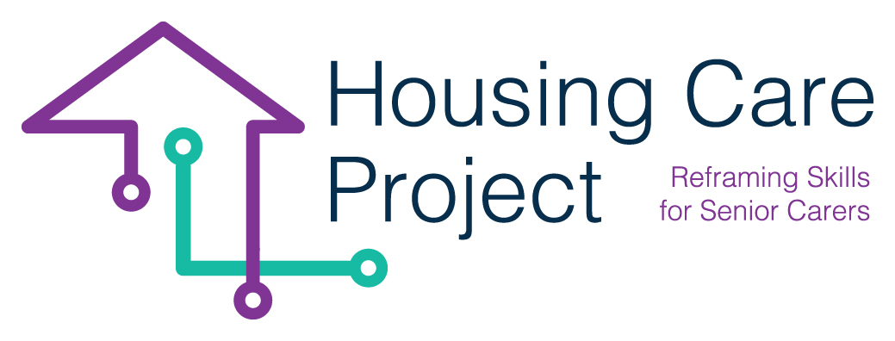

Exercices

**01** Introduction ………………………….… 2

**02** PDSA ……………………………..… 3

**03** Communication model …….… 5

**04** Methods ……..………….… 7



The European Commission support for the production of this publication does not constitute an endorsement of the contents which reflects the views only of the authors, and the Commission cannot be held responsi­ble for any use which may be made of the information contained therein 2021-1-IT01-KA220-VET-000032949

PDSA learning cycle

**PDSA Learning Cycle** (easy and manageable)

Set aside time

Perform

Test

Analyze

Cause

Goal

Plan

Yes – act

No – plan

Goal achieved

Evaluate

Share knowledge

Follow up

Training

Adjustments

Understand the situation

Start

**Exercise**:

Imagine a senior person who needs help to become part of a network and have easier access to or to find collectors in other European countries with the same interest in stamp collecting.

* Use the PSDA model to implement your plan.
* Describe and share with others what succeeded and what did not succeed and how you made adjustments.



The European Commission support for the production of this publication does not constitute an endorsement of the contents which reflects the views only of the authors, and the Commission cannot be held responsi­ble for any use which may be made of the information contained therein 2021-1-IT01-KA220-VET-000032949

Communication model

Risk of error =

Intention



Intention

Context

Medium

**Exercise**:

Think of a situation you have been in where communication was NOT optimal;

* Insert the communication into the model
* Analyse where in the model it did not work
* Explain to colleagues based on the model
* Describe how you want to do it differently and why



The European Commission support for the production of this publication does not constitute an endorsement of the contents which reflects the views only of the authors, and the Commission cannot be held responsi­ble for any use which may be made of the information contained therein 2021-1-IT01-KA220-VET-000032949

Methods

**Active listening**

* Avoid managing the speaker
* Avoid coming up with solutions
* Avoid thinking for the speaker

**The response model**

Cognitive – used to obtain and provide factual information

Affective – seeks into the other's feelings

**The parrot method and paraphrasing**

Parrot – repeat sentence or word

Paraphrasing – repeat what you have understood in your own words, and the other assesses whether it is correctly understood.

**The toolbox**

**About the conversation**:

The 4 layers of conversation (cliché, facts, opinion, feeling)

**Verbal techniques**:

Response; Expanding / delimiting, cognitive / affective, covering / confrontational

Repetitions, resumè, pauses

**Nonverbal Techniques**:

Touch, body language

**Exercise:**

You have agreed to help a citizen find Apps that can help manage daily life and remember to take medication and keep appointments with doctor, family and friends. She has a new smartphone and is very unsure if she can figure it all out.

Make a role-playing game 2 and 2 and play through how you want to approach the task and use all the techniques above.

Discuss and evaluate together and make suggestions on how you will do next.