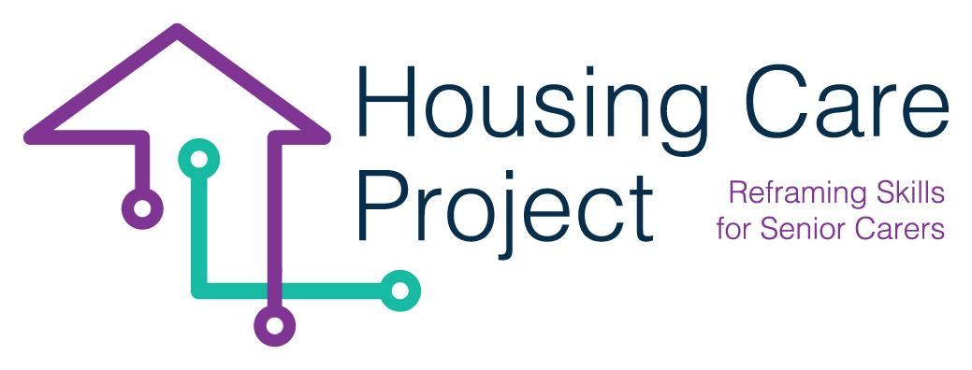

g
2022 – 2024
LTTA Madrid
By
SOSU OSTJYLLAND

www.housingcare.net
Tips and tricks Housing Care Project

- Uncover the need for technology (whose need is it and what will it solve?)
- Find the goal together.
- Uncover any obstacles to learning or goal achievement.
- Use questioning methodology and active listening.
- Repeat several times.
- Apply PDSA to plan, test, and adjust.
- Ask yourself; Do I teach someone something or do I do something for someone?
- Comply with GDPR.
- Think ethics into the task solution.
- Discuss with colleagues and learn from each other.
- No one becomes a world champion without practice.

The European Commission support for the production of this publication does not constitute an endorsement of the contents which reflects the views only of the authors, and the Commission cannot be held responsible for any use which may be made of the information contained therein 2021-1-IT01-KA220-VET-000032949

